“ShopWish – Shopping Wishlist & Save for Later”
A Project Report Submitted in the partial fulfillment of the requirements for the award of the degree of

BACHELOR OF TECHNOLOGY
In

DEPARTMENT OF COMPUTER SCIENCE ENGINNERING
By

T. S. S. S. ANANYA 2520030039
SUNKARA LOHITHA 2520030109

Under the Esteemed Guidance of

Dr. K MADHAVI REDDY
Assistant Professor
Department of Computer Science and Engineering




K L (Deemed to be) University DEPARTMENT OF COMPUTER SCIENCE ENGINEERING



Declaration

The Project Report entitled “ShopWish – Shopping Wishlist & Save for Later” is a record of Bonafide work of T. S. S. S. ANANYA - 2520030039, SUNKARA LOHITHA – 2520030109, submitted in partial fulfillment for the award of B. Tech in Computer Science and Engineering to the KL University. The results embodied in this report have not been copied from any other departments/University/Institute.

T. S. S. S. ANANYA – 2520030039

SUNKARA LOHITHA - 2520030109

K L (Deemed to be) University

DEPARTMENT OF COMPUTER SCIENCE ENGINEERING



CERTIFICATE

This is certify that the mini project based report entitled “ShopWish – Shopping Wishlist & Save for Later” is a bonafide work done and submitted by T. S. S. S. ANANYA - 2520030039, SUNKARA LOHITHA – 2520030109 in partial fulfillment of the requirements for the award of the degree of BACHELOR OF TECHNOLOGY in Department of Computer Science Engineering, K L (Deemed to be University), during the academic year 2025-2026.

Signature of the Guide

Signature of the Course Coordinator Signature of the HOD

ACKNOWLEDGEMENT
The success in this project would not have been possible but for the timely help and guidance rendered by many people. Our wish to express my sincere thanks to all those who has assisted us in one way or the other for the completion of my project.

Our greatest appreciation to my Course Coordinator Dr K. Madhavi , and my guide Dr K. Madhavi , Department of Computer Science which cannot be expressed in words for his/her tremendous support, encouragement and guidance for this project.

We express our gratitude to Dr. K . Chaitanya Kumar(CSE), Head of the Department for Computer Science Engineering for providing us with adequate facilities, ways and means by which we are able to complete this project-based Lab.

We thank all the members of teaching and non-teaching staff members, and also who have assisted me directly or indirectly for successful completion of this project. Finally, I sincerely thank my parents, friends and classmates for their kind help and cooperation during my work.

T. S. S. S. ANANYA – 2520030039

SUNKARA LOHITHA – 2520030109

Abstract

This application serves as a comprehensive digital companion designed to refine and simplify the modern online shopping journey. At its core, the system empowers users to move beyond cluttered tabs and forgotten bookmarks by providing a centralized hub to curate multiple, personalized collections of desired products. Whether planning a seasonal wardrobe update, a home renovation, or a holiday gift list, users can effortlessly organize their finds and move items between categories as their shopping priorities evolve.
To ensure shoppers never miss an opportunity, the platform acts as a proactive assistant. It monitors the status of saved items and delivers timely notifications regarding price reductions or stock replenishments. This feature transforms a passive list into an active tool for securing the best value and availability.
The user experience is prioritized through a clean, intuitive interface that remains consistent and fast across smartphones, tablets, and desktops. Furthermore, the inclusion of easy sharing options allows users to send their curated lists to friends and family, making collaborative shopping or gift-giving more interactive and efficient. By focusing on organization, real-time updates, and ease of use, the project creates a more intentional and stress-free way to manage the transition from browsing to buying.

Index

S.  No. | Chapters | Topics | Page.no
 |  | Acknowledgement
 |  | Abstract
1 | Introduction | - Background of the project  - Problem statement  - Scope of the project  - Objective(s)  - Importance of the application  - Target users/audience | 5-15
2 | System Requirements | - Hardware requirements  - Software requirements  - Development tools and frameworks | 16-21
3 | Technology Stack | - Front-end (e.g., React.js, Angular, HTML/CSS)  - Back-end (e.g., Node.js, Django, Spring Boot)  - Database (e.g., MongoDB, MySQL, PostgreSQL)  - Version Control (e.g., Git, GitHub)  - APIs or External services (e.g., Firebase, Stripe) | 22-32
4 | System Architecture | - High-level architecture diagram  - Description of each layer (frontend, backend, database)  - Deployment architecture (e.g., cloud, local, CI/CD  pipelines) | 33-36
5 | Design | 5.2 ER Diagram / Database schema | 37
6 | Implementation | - Module-wise implementation  - Front-end logic (UI rendering, state management)  - API integration  - Authentication & Authorization | 38-47
7 | Features | - List of main features  - How each feature works (user perspective + technical description) | 48-55
8 | Testing | - Postman testing (frontend/backend)  - Integration testing  - Tools used for testing  - Test cases and results | 56-64
9 | Deployment | - Steps to deploy  - Environment configuration  - Hosting of frontend and backend | 65-73
10 | Challenges & Limitations | - Issues faced during development  - Solutions applied  - Current limitations or known bugs | 74-82
11 | Future Enhancements | - Planned features  - Possible integrations or optimizations | 83-88
12 | Conclusion | - Summary of the project  - What was achieved  - Skills learned during development | 89-97
13 | References | - Books, tutorials, APIs, documentation sites used | 98-99

14 | Appendices | - Screenshots of the app  - Sample code snippets  - Installation/setup instructions  - User manual or guide  -Geo Tag photos with guide  -Review forms with guide signatures | 100-105

CHAPTER -1 INTRODUCTION

1.1 Background of the Project
The rapid growth of e-commerce has transformed the way consumers discover, compare, and purchase products. With online marketplaces such as Amazon, Flipkart, Myntra, Ajio, Littlebox, Nykaa, and many others offering millions of products across diverse categories, online shopping has become an integral part of everyday life. Consumers today frequently browse multiple websites before making purchasing decisions, comparing prices, reading reviews, exploring alternatives, and waiting for discounts or seasonal sales. While this abundance of choice benefits shoppers, it has also introduced a new challenge—the lack of a centralized system to organize products of interest across different platforms.
Most existing e-commerce platforms provide users with a basic wishlist feature. However, these wishlists are confined to individual websites and cannot be synchronized across multiple shopping platforms. As a result, users often maintain separate wishlists on different applications, making it difficult to remember saved products, compare options, or track items effectively. Many shoppers resort to taking screenshots, bookmarking webpages, or maintaining notes to remember products they intend to purchase later. These methods are inefficient, unorganized, and provide little support for long-term shopping planning.
Another significant limitation of current online shopping platforms is the absence of personalized organization. Traditional wishlists function as a single collection of saved products, offering little flexibility for categorization based on user interests. Modern consumers frequently wish to organize products into multiple collections such as Fashion, Electronics, Home Décor, Gifts, Travel Essentials, or Seasonal Purchases. Existing e-commerce websites rarely support this level of customization, resulting in cluttered wishlists that become increasingly difficult to manage over time.
Additionally, shoppers often miss valuable opportunities because they are unaware of price reductions, stock availability, or product updates. Monitoring multiple shopping websites manually for discounts and restocked items is time-consuming and impractical. The absence of centralized notifications reduces user engagement and often causes customers to lose track of products they intended to purchase. Similarly, transitioning products from a wishlist to the final purchase stage is not always seamless, as users must repeatedly search for previously saved items across different platforms.
It is within this context that ShopWish was conceived and developed. ShopWish is a comprehensive web-based wishlist aggregation and shopping management platform designed to simplify and personalize the online shopping experience. Rather than functioning as another e-commerce website, the system serves as a centralized shopping companion where users can discover products from multiple online marketplaces, organize them into customizable Pinterest-style wishboards, manage their shopping cart, and receive timely notifications about product activity. By bringing together products from various shopping platforms into a single organized environment, ShopWish eliminates fragmentation and enables users to manage their purchasing decisions more efficiently.
The ShopWish platform has been developed using modern frontend technologies to ensure scalability, responsiveness, and ease of use. The application is built using React.js, enabling the
creation of reusable and modular user interface components that improve maintainability and performance. Navigation throughout the application is managed using React Router, allowing users to seamlessly transition between authentication pages, product listings, wishboards, cart management, and profile pages within a single-page application architecture.
State management throughout the application is implemented using React Hooks, particularly useState and useEffect, to handle dynamic user interactions, page updates, and persistent data management. During development, LocalStorage serves as the client-side database, securely storing user accounts, authentication sessions, wishboards, shopping cart information, recently viewed products, and notifications without requiring a backend server. This architecture allows the application to simulate a real-world shopping platform while remaining lightweight and easy to deploy.
The application's interface has been designed using CSS3 with responsive layouts, modern gradients, reusable styling, and intuitive navigation to provide a visually appealing shopping experience across different screen sizes. Special emphasis has been placed on user experience by implementing Pinterest-inspired wishboards, reusable product cards, dynamic filtering, recently viewed products, and notification badges that mimic the functionality of modern commercial shopping applications. Furthermore, the overall architecture has been designed to facilitate future integration with backend technologies such as Node.js, Express.js, MongoDB, or MySQL, enabling secure authentication, real-time product synchronization, and API-based price tracking in subsequent development phases.
The system is organized into five fully functional modules that together deliver a complete shopping management solution. The Authentication and User Management module provides secure registration, login, profile management, and personalized user sessions. The Product Management module enables users to browse products, apply search and filtering mechanisms, and access detailed product information while maintaining a recently viewed history. The Wishlist Management module serves as the core of the application by allowing users to create multiple customizable wishboards, organize products into themed collections, rename boards, and manage saved items efficiently. The Cart Management module facilitates seamless movement of products from wishboards into the shopping cart while supporting quantity management and synchronized product removal. Finally, the Notification and Alert module enhances user engagement by providing simulated price drop alerts, stock availability notifications, activity tracking, and notification badges that keep users informed about important product updates.
Particular emphasis has been placed on the Wishlist Management module because it distinguishes ShopWish from conventional shopping applications. Inspired by Pinterest's board-based organization system, users are able to create multiple personalized wishboards tailored to different shopping goals and interests. This approach significantly improves product organization, reduces clutter, and enables users to manage purchases in a more intuitive and visually structured manner.
In summary, ShopWish represents a modern approach to digital shopping organization by addressing several limitations of existing e-commerce wishlists. By combining centralized product management, customizable wishboards, intelligent cart synchronization, personalized notifications, and a responsive user interface, the platform demonstrates how frontend technologies can be leveraged to improve shopping convenience and user engagement. The project serves as a scalable foundation for future enhancements such as browser extension integration, real-time price monitoring, AI-powered product recommendations, and multi-platform synchronization, positioning ShopWish as a comprehensive personal shopping companion rather than simply another online marketplace.

1.2 Problem Statement
In today's digital era, online shopping has become an essential part of everyday life. Consumers regularly browse multiple e-commerce platforms such as Amazon, Flipkart, Myntra, Ajio, Littlebox, Nykaa, and others to compare products, explore offers, and find the best deals. While these platforms provide convenient shopping experiences individually, they lack a unified system that allows users to organize products across different websites. As a result, shoppers often struggle to keep track of products they are interested in purchasing.
Currently, each shopping platform provides its own independent wishlist feature, but these wishlists remain isolated within their respective applications. A product saved on Amazon cannot be viewed alongside products saved on Myntra or Flipkart. Consequently, users are forced to maintain multiple wishlists across different websites, making it difficult to organize products, compare options, or remember items they intend to purchase in the future.
Another major limitation of existing shopping platforms is the lack of personalized organization. Most websites offer only a single wishlist where all saved products are stored together. As the number of saved items increases, users find it difficult to categorize products based on different interests such as Fashion, Electronics, Home Décor, Travel, Gifts, or Seasonal Purchases. The absence of multiple customizable collections leads to cluttered wishlists and an inefficient shopping experience.
Product tracking is another significant challenge. Users frequently miss discounts, limited-time offers, and stock availability updates because they have no centralized platform to monitor products saved across different shopping websites. Instead, they must repeatedly visit each website to check whether a product's price has changed or if an out-of-stock item has become available again. This manual process is time-consuming and often causes users to miss valuable purchasing opportunities.
Furthermore, there is no simple way to manage the progression of products from "saved for later" to "ready to purchase." Existing platforms generally separate wishlists and shopping carts without providing efficient synchronization between them. Users often have to search for products again or manually move items between lists, increasing the overall effort involved in online shopping.
Another limitation is the absence of meaningful shopping activity tracking. Users cannot easily view recently explored products, monitor their shopping history, or receive personalized notifications related to their saved items. This reduces user engagement and makes it difficult to continue shopping from where they previously left off.
Additionally, shoppers who browse products across multiple platforms often resort to taking screenshots, saving browser bookmarks, or maintaining personal notes to remember products of interest. These methods are unorganized, difficult to maintain, and fail to provide an integrated shopping management experience.
All these challenges collectively create a fragmented and inefficient shopping workflow that affects user convenience and decision-making. There is a clear need for a centralized, user-friendly, and organized platform that enables shoppers to discover products, manage multiple personalized wishboards, synchronize shopping activities, organize products efficiently, and receive timely notifications about important product updates regardless of the shopping platform.
The ShopWish platform is designed specifically to address these problems by providing a centralized wishlist aggregation and shopping management system. Through secure user authentication, dynamic product management, Pinterest-inspired wishboards, synchronized cart management, and personalized notification services, ShopWish simplifies the online shopping journey and enables users to manage their desired products more efficiently. The platform transforms scattered shopping activities into a structured, organized, and engaging experience while providing a scalable foundation for future integration with real-time e-commerce services and browser extension support.

1.3 Scope of the Project
The ShopWish – Wishlist Aggregation and Shopping Management System is designed with a broad and practical scope that simplifies the online shopping experience by providing users with a centralized platform to organize, manage, and track products from multiple e-commerce websites. The scope of this project includes both the functionalities implemented in the current system and the future enhancements that can transform it into a comprehensive personal shopping assistant.

1. User Authentication and Profile Management
The first scope of this project is to provide secure user authentication and personalized account management. Users can create their own accounts, log in securely, and maintain separate shopping data without interfering with other users. Each user's wishboards, shopping cart, recently viewed products, notifications, and profile information are stored independently using LocalStorage. This ensures personalized shopping experiences while maintaining data privacy. The system also supports session management, allowing users to remain logged in until they choose to sign out.

2. Product Discovery and Management
The project provides a centralized product browsing experience where users can explore products from multiple shopping platforms in one place. Every product contains detailed information including product images, prices, ratings, descriptions, shopping platform names, and direct purchase links. Users can search products by name and apply filters based on category and shopping website, making product discovery faster and more organized. Recently viewed products are also maintained so that users can quickly revisit products they have explored earlier without searching again.

3. Pinterest-Style Wishlist (Wishboard) Management
The core scope of this project is the implementation of customizable Pinterest-inspired wishboards. Instead of storing every saved product in a single wishlist, users can create multiple personalized boards according to their interests such as Fashion, Electronics, Home Décor, Travel, Gifts, or Future Purchases. Products can be added, removed, or organized across different boards, while users can also rename or delete boards whenever required. This feature significantly improves shopping organization and offers greater flexibility than traditional wishlist systems available on most e-commerce platforms.

4. Shopping Cart Management
The project extends beyond wishlists by providing a complete shopping cart management system. Products saved in wishboards can be moved directly into the shopping cart without needing to search for them again. Users can increase or decrease product quantities, remove products from the cart, and monitor the total cost of their selected items. Proper synchronization is maintained between the wishboards and shopping cart to ensure products are updated consistently, creating a smooth transition from product discovery to purchasing.

5. Notification and Activity Tracking
The system includes a notification module that keeps users informed about important shopping activities. Notifications are generated whenever products are added to wishboards, moved to the shopping cart, or removed from saved collections. The application also simulates price drop alerts and stock availability notifications, helping users stay updated about products they are interested in. Users can view notification history, mark notifications as read, or clear them entirely, making shopping interactions more engaging and personalized.

6. Personalized Shopping Experience
Another important scope of the project is delivering a personalized shopping environment. Each user's shopping history, recently viewed products, wishboards, shopping cart, and notifications are maintained independently through LocalStorage. This allows multiple users to access the application from the same browser while viewing only their own data. The personalized dashboard ensures that every shopping activity is tailored to the logged-in user.

7. Responsive User Interface and Navigation
The project also focuses on providing a clean, responsive, and user-friendly interface. The application is built using reusable React components and modern CSS styling to ensure consistent design across all pages. Navigation between modules is handled using React Router, enabling a seamless single-page application experience without unnecessary page reloads. The responsive design ensures that the application can be easily adapted for desktops, tablets, and mobile devices.

8. Future Scope
The project has significant potential for future enhancements. Instead of manually maintaining product data, ShopWish can be integrated with live e-commerce APIs to fetch real-time product information, prices, ratings, and availability. A browser extension can also be developed to allow users to save products directly from shopping websites such as Amazon, Flipkart, Myntra, Ajio, Nykaa, and Littlebox into their personalized wishboards with a single click.
Future versions may also include AI-powered product recommendations based on browsing history and saved products, real-time price tracking with automatic alerts, stock availability monitoring, collaborative wishboards that can be shared with family and friends, gift registry support, and cloud-based synchronization using Firebase or MongoDB. Secure backend integration using Node.js and Express.js will allow users to access their shopping data across multiple devices while enabling real-time updates and enhanced security.
In conclusion, the ShopWish – Wishlist Aggregation and Shopping Management System provides a practical and scalable solution to the fragmented nature of online shopping. By combining secure user authentication, centralized product discovery, Pinterest-inspired wishboards, shopping cart synchronization, personalized notifications, and responsive design, the system simplifies product organization and improves the overall shopping experience. More than just a college project, ShopWish serves as a strong foundation for a future smart shopping assistant capable of integrating multiple e-commerce platforms into one unified and user-friendly ecosystem.

.1.4 Objectives of the Project
The primary aim of the ShopWish – Wishlist Aggregation and Shopping Management System is to provide users with a centralized, organized, and personalized platform for managing products from multiple online shopping websites. The project has been developed with a set of clear and practical objectives that address common challenges faced by online shoppers. Each objective focuses on improving product organization, shopping convenience, and user engagement by utilizing modern web technologies and an intuitive user interface.

1. To Provide Secure User Registration and Authentication
One of the primary objectives of this project is to provide users with a secure and personalized account management system. The application allows users to register, log in, and maintain their own shopping data independently. Each user's wishboards, shopping cart, recently viewed products, notifications, and profile information are stored separately using LocalStorage. The objective is to ensure that every user enjoys a secure and personalized shopping experience while maintaining privacy and preventing unauthorized access to another user's data.

2. To Provide a Centralized Product Browsing Platform
Another important objective of the project is to simplify product discovery by displaying products from multiple shopping platforms within a single interface. Instead of visiting several e-commerce websites individually, users can browse products containing images, prices, ratings, descriptions, shopping platform names, and direct purchase links. The application also provides search functionality and category-based filtering, enabling users to quickly locate products according to their interests and shopping preferences.

3. To Implement Pinterest-Style Wishboard Management
The core objective of ShopWish is to provide users with an organized and visually appealing wishlist management system inspired by Pinterest boards. Rather than storing every saved product in a single wishlist, users can create multiple personalized wishboards based on categories such as Fashion, Electronics, Home Décor, Gifts, Travel, or Future Purchases. The system allows users to create, rename, delete, and manage multiple boards while organizing products according to their personal preferences. This objective significantly improves shopping organization and makes product management more flexible and efficient.

4. To Simplify Shopping Cart Management
The project aims to provide a smooth transition between saving products and preparing for purchase through an integrated shopping cart management system. Users can move products directly from their wishboards into the shopping cart, update product quantities, remove unwanted items, and view the total value of their selected products. Proper synchronization between the wishboards and the shopping cart ensures that products remain consistent across modules while reducing the effort required to complete the shopping process.

5. To Keep Users Updated Through Notifications and Activity Tracking
One of the major objectives of the project is to enhance user engagement by providing timely notifications related to shopping activities. The application generates alerts whenever products are added to wishboards, moved to the shopping cart, or removed from saved collections. It also simulates price drop notifications and stock availability alerts to encourage users to revisit products they are interested in. A dedicated notification center allows users to view their activity history, mark notifications as read, and clear them whenever required.

6. To Improve Product Accessibility Through Search, Filtering, and Recently Viewed Products
The project aims to improve product accessibility by allowing users to search products efficiently and filter them based on category and shopping platform. In addition, the application maintains a recently viewed products section so users can quickly return to products they have previously explored without repeating their search. This objective reduces browsing time and improves the overall shopping experience by making product discovery faster and more convenient.

7. To Develop a Responsive and User-Friendly Shopping Interface
Another key objective is to build a modern, responsive, and easy-to-use web application that provides a seamless shopping experience across different devices. The application utilizes reusable React components, React Router for smooth navigation, and responsive CSS layouts to deliver an attractive interface with consistent user interactions. The objective is to create a shopping companion that is intuitive, visually appealing, and accessible to users with varying levels of technical experience.

8. To Build a Scalable and Future-Ready Shopping Platform
The final objective of the project is to develop a scalable application that can be extended into a fully functional real-world shopping assistant. The current implementation uses React.js and LocalStorage for frontend data management, but the architecture has been designed to support future integration with Node.js, Express.js, MongoDB, or MySQL for secure cloud-based storage and user authentication. Future enhancements may include browser extension support for one-click product saving, real-time product synchronization with e-commerce websites, AI-powered product recommendations, automatic price tracking, collaborative wishboards, cloud synchronization across devices, and live notifications. The objective is to ensure that ShopWish evolves from an academic project into a practical solution capable of simplifying online shopping for users across multiple e-commerce platforms.
In conclusion, the ShopWish – Wishlist Aggregation and Shopping Management System is designed with clear, user-focused objectives that address the limitations of traditional online shopping platforms. By combining secure authentication, centralized product management, Pinterest-inspired wishboards, shopping cart synchronization, intelligent notifications, and a responsive user interface, the project demonstrates how modern web technologies can be leveraged to create a more organized, efficient, and engaging shopping experience for users.

1.5 Importance of the Application
The ShopWish – Wishlist Aggregation and Shopping Management System is an innovative web application developed to simplify and improve the online shopping experience. With the rapid growth of e-commerce, consumers regularly browse multiple shopping platforms such as Amazon, Flipkart, Myntra, Ajio, Littlebox, Nykaa, and many others before making purchasing decisions. While these platforms offer a wide variety of products, they operate independently, forcing users to manage separate wishlists, shopping carts, and product histories on each website. ShopWish addresses this problem by providing a centralized platform where users can organize products, create personalized wishboards, manage shopping carts, and receive notifications—all within a single application. The system improves shopping convenience, enhances organization, and enables users to make smarter purchasing decisions.
One of the most significant advantages of ShopWish is its ability to provide a centralized product management platform. Traditional shopping websites allow users to save products only within their individual platforms, making it difficult to keep track of products across multiple websites. ShopWish brings products from different shopping platforms into a single interface where users can browse, compare, organize, and revisit products easily. By maintaining product information such as images, prices, ratings, descriptions, and shopping platform details in one place, the application reduces the need to switch repeatedly between multiple e-commerce websites.
Another important benefit of the application is its Pinterest-inspired wishboard management system. Unlike conventional shopping websites that provide only a single wishlist, ShopWish enables users to create multiple customizable wishboards according to their personal interests and shopping goals. Users can organize products into collections such as Fashion, Electronics, Home Décor, Travel Essentials, Gift Ideas, or Future Purchases. This organized approach eliminates clutter, makes saved products easier to manage, and allows users to plan purchases more efficiently.
The application also plays a vital role in improving product accessibility and shopping convenience. Finding previously viewed or saved products on traditional shopping websites often requires users to search again or browse through lengthy wishlists. ShopWish overcomes this problem by providing advanced search functionality, category-based filtering, website-based filtering, and a Recently Viewed Products feature. These capabilities allow users to locate products quickly, continue shopping from where they previously left off, and reduce the time spent searching for desired items.
Another significant contribution of ShopWish is its integrated shopping cart management system. Users can seamlessly move products from their personalized wishboards to the shopping cart without searching for them again. The application allows users to increase or decrease product quantities, remove unwanted products, and calculate the total value of selected items. Synchronization between the wishboards and shopping cart ensures that products are managed consistently throughout the shopping process. This smooth transition from product discovery to purchase preparation significantly enhances the overall user experience.
One of the key strengths of ShopWish is its notification and activity tracking system. Modern online shoppers often miss important price reductions, stock availability updates, or shopping reminders because they must manually monitor multiple websites. ShopWish addresses this challenge by generating notifications whenever products are added to wishboards, moved to the shopping cart, or updated within the application. Simulated price drop alerts, stock availability notifications, and activity history encourage users to revisit products and remain engaged with their shopping plans. These features create a more interactive and personalized shopping experience.
The application also contributes to improving shopping organization and decision-making. Many users currently rely on screenshots, browser bookmarks, notes, or memory to remember products they wish to purchase in the future. These methods are difficult to maintain and often result in forgotten products or missed opportunities. ShopWish replaces these fragmented approaches with a structured digital system where all shopping interests are stored, categorized, and easily accessible. This enables users to compare products, prioritize purchases, and make more informed buying decisions.
Another important advantage of ShopWish is its personalized user experience. Every registered user has an independent account where their wishboards, shopping cart, notifications, recently viewed products, and profile information are stored separately using LocalStorage. Multiple users can access the application on the same device while viewing only their own shopping information. This personalized environment improves usability and ensures that shopping activities remain organized and private for each individual user.
From a technological perspective, ShopWish demonstrates the effective use of modern frontend web development technologies. The application is developed using React.js, allowing the use of reusable components that improve maintainability, scalability, and performance. React Router provides seamless navigation between modules without requiring full page reloads, while React Hooks such as useState and useEffect manage dynamic data and user interactions efficiently. LocalStorage enables persistent client-side data storage, allowing users to retain their shopping information across browser sessions without requiring a backend database during development. These technologies collectively demonstrate best practices in modern web application development.
The application also supports the digital transformation of personal shopping management. As consumers increasingly rely on online shopping, there is a growing need for intelligent tools that simplify shopping across multiple platforms. ShopWish serves as a digital shopping companion that helps users organize products, plan future purchases, and manage shopping activities more efficiently. Its responsive interface and intuitive navigation make the platform accessible to users of varying technical backgrounds while improving the overall shopping experience.
Another important aspect of ShopWish is its scalability and future potential. Although the current implementation utilizes LocalStorage for data persistence, the application's architecture has been designed to support future integration with backend technologies such as Node.js, Express.js, MongoDB, or MySQL. Future versions of the application can incorporate browser extension support that allows users to save products directly from websites such as Amazon, Flipkart, Myntra, and other e-commerce platforms with a single click. Additional enhancements may include AI-powered product recommendations, real-time price tracking, stock monitoring, collaborative wishboards, cloud synchronization across multiple devices, and secure user authentication using cloud databases. These improvements have the potential to transform ShopWish into a comprehensive personal shopping assistant capable of supporting millions of users.
The application also encourages smarter financial planning by helping users organize purchases according to priorities and budgets. Instead of making impulsive buying decisions, users can maintain categorized wishboards, monitor products over time, and purchase items when prices become more favorable. This organized approach promotes responsible spending and improves overall shopping satisfaction.
In conclusion, the ShopWish – Wishlist Aggregation and Shopping Management System is a practical and valuable web application that addresses many limitations of existing online shopping platforms. It centralizes product management, provides Pinterest-inspired wishboard organization, simplifies shopping cart operations, improves product accessibility, enhances user engagement through notifications, and delivers a personalized shopping experience using modern web technologies. Beyond being a college project, ShopWish represents a scalable foundation for the next generation of intelligent shopping assistants that can integrate multiple e-commerce platforms into one unified, efficient, and user-friendly ecosystem. The project demonstrates how technology can be used to simplify online shopping, improve product organization, and empower users to make smarter purchasing decisions.
1.6 Target Users / Audience
The ShopWish – Wishlist Aggregation and Shopping Management System is designed to serve a wide range of users involved in online shopping. The application provides a centralized platform where users can organize products, create personalized wishboards, manage shopping carts, and track their shopping activities across multiple e-commerce platforms. The primary target users of the application are described below.

1. Online Shoppers
Online shoppers are the primary users of the application. They can browse products from different shopping platforms, search for products, filter items by category or website, and save products into personalized wishboards. Users can create multiple boards for different purposes such as Fashion, Electronics, Home Essentials, Gift Ideas, or Future Purchases. The application helps them organize their shopping interests in a structured and convenient manner.

2. Frequent E-Commerce Customers
Customers who regularly shop from multiple e-commerce websites such as Amazon, Flipkart, Myntra, Ajio, Littlebox, and similar platforms can greatly benefit from the system. Instead of maintaining separate wishlists on different websites, they can manage all their favorite products in one centralized application. This reduces confusion and makes it easier to compare and organize products across platforms.

3. Budget-Conscious Buyers
Users who carefully plan their purchases and monitor products before buying are another important audience of the application. They can save products into categorized wishboards, receive simulated price-drop and stock availability notifications, and move products to the shopping cart whenever they are ready to purchase. This helps users avoid impulsive buying and make more informed financial decisions.

4. Students and Young Professionals
Students and young working professionals frequently explore products online before making purchasing decisions. ShopWish enables them to organize products according to their needs, such as study essentials, gadgets, fashion accessories, or home items. The application provides an easy way to manage future purchases while keeping track of products they intend to buy later.

5. Shopping Enthusiasts
People who enjoy exploring new products, comparing brands, and discovering trending items can use the application to maintain organized collections of products. The Pinterest-inspired wishboard feature allows users to create visually organized boards based on their personal interests, making product management more enjoyable and efficient.

6. System Administrators and Developers
Administrators and developers involved in maintaining or extending the application are also important users of the system. They can monitor application functionality, update product information, enhance existing features, and integrate future technologies such as cloud databases, real-time price tracking, browser extensions, and AI-powered recommendations. The modular React architecture makes the application easy to maintain and expand.

Conclusion
The ShopWish – Wishlist Aggregation and Shopping Management System is designed to benefit a diverse group of users, including online shoppers, frequent e-commerce customers, budget-conscious buyers, students, young professionals, shopping enthusiasts, and system developers. By providing a centralized platform for product organization, Pinterest-style wishboard management, shopping cart synchronization, notifications, and personalized shopping experiences, the application simplifies online shopping and enables users to manage products more efficiently across multiple e-commerce platforms.

CHAPTER -2 SYSTEM REQUIREMENT

2.1 Hardware Requirements
Hardware requirements form the foundation of the ShopWish – Wishlist Aggregation and Shopping Management System and define the physical resources necessary for the successful development, testing, deployment, and operation of the application. Since the project is a web-based shopping management platform designed to provide user authentication, product browsing, Pinterest-style wishboard management, shopping cart operations, and notification services, the underlying hardware should support smooth application development and efficient user interaction. The hardware requirements can be categorized into development environment requirements and end-user requirements. The development environment requires sufficient computing resources for coding, debugging, testing, and running the application locally, while end users only require standard computing devices with internet access to use the application.
The development system should ideally be equipped with an Intel Core i5 processor or an equivalent AMD Ryzen 5 processor operating at a minimum clock speed of 2.4 GHz. A multi-core processor is recommended because developers frequently execute multiple applications simultaneously, including Visual Studio Code, web browsers, Git, Node.js, React development servers, and debugging tools. During development, the processor is responsible for compiling React components, rendering the user interface, and supporting continuous updates through Vite's hot module replacement. A capable processor significantly improves application responsiveness and overall development efficiency.
Memory is another important hardware component required for efficient application development. A minimum of 8 GB RAM is recommended to ensure the smooth execution of Visual Studio Code, React development tools, browser instances, and testing environments. Since modern web development often involves multiple browser tabs, extensions, and debugging utilities running simultaneously, adequate memory prevents system slowdowns and improves multitasking performance. For larger projects or future enhancements, 16 GB RAM is recommended to provide an even smoother development experience.
Storage plays a crucial role in maintaining project files, React source code, documentation, images, product assets, CSS files, and project backups. The development machine should provide at least 250 GB of available storage, preferably using a Solid State Drive (SSD). SSD storage offers significantly faster file access, quicker project loading, and improved application startup times compared to traditional Hard Disk Drives (HDDs). Additional storage space may also be used for maintaining project versions, screenshots, reports, and future feature implementations.
A Full HD monitor with a resolution of 1920 × 1080 pixels is recommended for efficient frontend development and interface design. A high-resolution display enables developers to view source code, browser output, debugging consoles, and design references simultaneously, improving productivity and simplifying responsive web design testing. Standard input devices such as a keyboard and mouse are essential for development activities, while smartphones and tablets may be used to verify the application's responsive design across different screen sizes.
From a deployment perspective, the ShopWish application can be hosted on a local development server during implementation or deployed to cloud-based hosting platforms such as Vercel, Netlify, or GitHub Pages. If future backend integration is implemented using Node.js, Express.js, and MongoDB or MySQL, a server equipped with a quad-core processor, 16 GB RAM, and SSD storage would be sufficient to support multiple concurrent users. Cloud hosting services can provide scalability, automated deployment, reliable uptime, and secure application access as the project grows.
The hardware requirements for end users are relatively modest. Users can access ShopWish using standard desktop computers, laptops, tablets, or smartphones. A dual-core processor, 4 GB RAM, and any modern web browser such as Google Chrome, Mozilla Firefox, Microsoft Edge, or Safari are sufficient for smooth operation. Since the application follows a responsive web design approach, it automatically adapts to different screen sizes and device types, allowing users to browse products, manage wishboards, use the shopping cart, and receive notifications without requiring specialized hardware.
An active internet connection is recommended when the application is deployed online. However, during development, many core features such as user authentication, product management, wishboards, shopping cart operations, and notifications utilize LocalStorage, allowing data to persist locally within the browser without requiring a backend database. This makes the application lightweight and suitable for demonstration purposes while also providing a strong foundation for future cloud-based deployment.
In conclusion, the hardware requirements of the ShopWish – Wishlist Aggregation and Shopping Management System are designed to balance performance, affordability, and accessibility. Moderate hardware resources are sufficient for application development and deployment, while end users require only standard computing devices and modern web browsers to access the system. This ensures that ShopWish remains easy to develop, simple to deploy, and accessible to a wide range of users across different platforms and devices.

2.2 Software Requirements
Software requirements define the technological environment necessary for designing, developing, testing, deploying, and maintaining the ShopWish – Wishlist Aggregation and Shopping Management System. As a web-based shopping management application, ShopWish relies on modern frontend technologies that provide dynamic functionality, responsive design, efficient state management, and an intuitive user experience. The selected software stack emphasizes simplicity, portability, scalability, and cross-platform compatibility, making the application suitable for both academic development and future real-world deployment.
The operating system forms the foundation of the software environment. The development and testing of ShopWish can be performed on Windows 10, Windows 11, Ubuntu Linux, or macOS. Windows provides excellent compatibility with modern web development tools such as Visual Studio Code, Node.js, and Git. Ubuntu Linux offers stability, open-source flexibility, and efficient resource utilization, making it suitable for future deployment on web servers. macOS also provides a reliable environment for frontend development and browser compatibility testing across multiple platforms.
Since ShopWish is a browser-based application, compatibility with modern web browsers is an essential software requirement. The application fully supports Google Chrome, Mozilla Firefox, Microsoft Edge, and Safari. These browsers provide complete support for modern web standards including HTML5, CSS3, JavaScript (ES6), and React.js. Browser compatibility ensures that users experience consistent functionality, responsive layouts, and smooth navigation regardless of the browser they choose.
The core frontend framework used in the development of ShopWish is React.js. React enables the application to be built using reusable and modular components such as the Navbar, Product Cards, Wishboards, Shopping Cart, Notifications, and User Profile. This component-based architecture improves maintainability, simplifies code reuse, and enhances application performance through efficient rendering. React Hooks such as useState and useEffect are utilized to manage dynamic data, user interactions, and application state throughout the system.
The project uses React Router DOM for navigation between different modules of the application. React Router enables seamless navigation between pages such as Home, Products, Wishboards, Cart, Notifications, Profile, Login, and Registration without requiring full page reloads. This creates a Single Page Application (SPA) experience that improves speed and provides smoother user interaction.
HTML5 serves as the structural foundation of the application. It defines the layout of web pages, navigation menus, forms, product listings, shopping carts, wishboards, and user profile pages. The semantic elements provided by HTML5 improve accessibility, maintainability, and compatibility with modern web standards while creating a well-organized application structure.
CSS3 is responsible for the visual presentation and responsive design of ShopWish. Through flexible layouts, Grid and Flexbox, media queries, animations, hover effects, and custom styling, CSS3 provides an attractive and user-friendly interface. Responsive design ensures that the application adapts effectively to desktops, laptops, tablets, and smartphones, allowing users to enjoy a consistent shopping experience across multiple devices.
JavaScript (ES6) provides the dynamic functionality of the application. It handles user authentication, product searching, category filtering, website filtering, wishboard creation, shopping cart operations, notification management, recently viewed products, and client-side validation. JavaScript enables interactive user experiences while eliminating unnecessary page reloads and ensuring smooth communication between different components of the application.
The development environment utilizes Node.js as the JavaScript runtime and Vite as the frontend build tool. Node.js provides the runtime required to execute development dependencies and package management, while Vite offers fast project initialization, hot module replacement (HMR), and rapid code compilation. Together, these tools significantly improve development speed and productivity.
The application uses npm (Node Package Manager) to install and manage project dependencies, including React, React Router DOM, and other required packages. npm simplifies dependency management, version control, and project maintenance throughout the development lifecycle.
For code development and debugging, Visual Studio Code (VS Code) serves as the primary Integrated Development Environment (IDE). VS Code provides syntax highlighting, intelligent code completion, debugging support, integrated terminal access, Git integration, and extensive extension support, making it an ideal environment for modern React application development.
The application utilizes the browser's LocalStorage API to persist user information and application data. LocalStorage stores user accounts, current login sessions, wishboards, shopping cart contents, notifications, and recently viewed products directly within the user's browser. This lightweight storage mechanism eliminates the need for a backend database during the initial implementation phase while allowing data to persist across browser sessions. Future versions of the application can easily integrate cloud databases such as MongoDB or MySQL for permanent and scalable data storage.
Version control is managed using Git, with the project being hosted on GitHub. Git enables developers to track code changes, maintain version history, collaborate effectively, and restore previous project versions when required. GitHub provides secure cloud-based repository hosting and simplifies project sharing and collaboration.
Basic security mechanisms are implemented throughout the application using client-side validation and controlled LocalStorage access. User registration and login forms validate required fields before processing data, reducing invalid input and improving application reliability. Future enhancements may include secure authentication using JWT, encrypted passwords, backend validation, cloud database integration, HTTPS communication, and role-based access control for improved security.
Overall, the software requirements of the ShopWish – Wishlist Aggregation and Shopping Management System provide a modern, reliable, and scalable development environment. The selected technologies ensure efficient application development, responsive user interfaces, smooth navigation, effective state management, and persistent data storage while providing a strong foundation for future enhancements such as cloud deployment, browser extension integration, AI-powered recommendations, and real-time synchronization with multiple e-commerce platforms.

2.3 Development Tools and Frameworks

The successful development of the ShopWish – Wishlist Aggregation and Shopping Management System depends on the use of modern development tools, frameworks, and supporting technologies that simplify coding, testing, debugging, and project management. These tools improve developer productivity, enhance software quality, and ensure that the application remains scalable, maintainable, and easy to extend in the future.
Visual Studio Code (VS Code) serves as the primary Integrated Development Environment (IDE) used throughout the project. VS Code provides intelligent code completion (IntelliSense), syntax highlighting, integrated debugging, extension support, terminal access, and Git integration. Its lightweight architecture and extensive marketplace of extensions make it an ideal environment for developing React-based web applications. Features such as auto-formatting, live error detection, and integrated terminal significantly improve development efficiency.
The frontend of ShopWish is developed using React.js, a modern JavaScript library for building dynamic and component-based user interfaces. React enables the application to be divided into reusable components such as the Navbar, Product Cards, Wishboards, Shopping Cart, Notifications, Profile, and Authentication pages. This modular architecture improves code reusability, maintainability, and application performance while simplifying future feature additions.
The project uses Vite as its frontend build tool and development server. Vite offers extremely fast project startup, efficient module bundling, and Hot Module Replacement (HMR), allowing developers to see code changes instantly without refreshing the browser. This significantly reduces development time and provides a smoother coding experience compared to traditional build tools.
Node.js provides the JavaScript runtime environment required for executing development dependencies and managing the React application during development. Although ShopWish currently operates as a frontend application without a backend server, Node.js is essential for running the Vite development server and installing project packages through npm.
Package management is handled using Node Package Manager (npm). npm is responsible for installing, updating, and maintaining project dependencies such as React, React Router DOM, and other third-party libraries. It simplifies dependency management, version updates, and project configuration while ensuring consistency across different development environments.
Navigation within the application is implemented using React Router DOM. This routing library enables seamless navigation between pages such as Home, Products, Product Details, Wishboards, Board Pages, Shopping Cart, Notifications, Login, Registration, and Profile without requiring full page reloads. React Router creates a smooth Single Page Application (SPA) experience and improves overall user interaction.
Version control is managed using Git, allowing developers to track source code changes, maintain version history, create branches for new features, and restore previous versions whenever necessary. Git improves collaboration, reduces development risks, and supports systematic software maintenance throughout the project lifecycle.
GitHub serves as the cloud-based repository hosting platform for the project. It provides secure source code storage, version backup, collaboration features, issue tracking, documentation support, and project sharing. GitHub enables multiple developers to contribute to the project efficiently while maintaining a complete history of all code modifications.
The project extensively utilizes Browser Developer Tools available in Google Chrome, Mozilla Firefox, and Microsoft Edge for debugging and testing purposes. These tools provide access to JavaScript console logs, LocalStorage inspection, responsive design testing, DOM inspection, CSS debugging, performance monitoring, and network analysis. Browser developer tools play a crucial role in identifying runtime errors, testing application functionality, and optimizing user interface performance.
LocalStorage is used as the client-side storage mechanism throughout the application. It stores user accounts, login sessions, wishboards, shopping cart information, notifications, and recently viewed products directly within the browser. LocalStorage allows data to persist across browser sessions without requiring a backend database, making it highly suitable for frontend development and demonstration purposes.
Responsive design testing is performed using browser device simulators and responsive design tools. These tools allow developers to verify that the application adapts correctly to desktops, laptops, tablets, and smartphones. Testing across different screen sizes ensures that ShopWish provides a consistent and user-friendly experience regardless of the device being used.
The project also makes extensive use of React Hooks, particularly useState and useEffect, for state management and lifecycle handling. These built-in React features simplify the management of dynamic data, user interactions, LocalStorage synchronization, and component rendering without requiring complex programming patterns.
In summary, the combination of Visual Studio Code, React.js, Vite, Node.js, npm, React Router DOM, Git, GitHub, Browser Developer Tools, React Hooks, and LocalStorage provides a complete and modern development ecosystem for ShopWish. These tools and frameworks ensure efficient implementation, testing, debugging, maintenance, and future scalability while supporting the development of a responsive, reliable, and user-friendly shopping management application.

2.4 Conclusion
The system requirements of the ShopWish – Wishlist Aggregation and Shopping Management System have been carefully selected to ensure smooth performance, user accessibility, responsiveness, and scalability. The hardware requirements provide sufficient resources for efficient development and deployment while maintaining minimal specifications for end users. The software environment, built using React.js, HTML5, CSS3, JavaScript, Vite, and modern development tools, ensures reliable operation, component reusability, and cross-platform compatibility. Together, these technologies establish a strong foundation for features such as user authentication, product browsing, Pinterest-style wishboard management, shopping cart operations, and notification services. Furthermore, the application's modular architecture supports future enhancements, including cloud database integration, browser extension support, real-time price tracking, AI-powered recommendations, and synchronization across multiple e-commerce platforms. This combination of usability, performance, and scalability makes ShopWish a practical, efficient, and future-ready solution for modern online shopping management.

CHAPTER-3 TECHNOLOGY STACK

3.1 Front-End Design
The front-end of the ShopWish – Wishlist Aggregation and Shopping Management System represents the user interface through which users interact with the application. It is responsible for displaying products, managing wishboards, handling shopping cart operations, and providing notifications through an intuitive and visually appealing interface. Since ShopWish is a web-based shopping management application, the front-end is designed with a strong emphasis on simplicity, responsiveness, ease of navigation, and an engaging user experience. The primary objective of the front-end is to enable users to browse products, organize wishlists into Pinterest-style boards, manage shopping activities, and access all features without requiring any technical knowledge.
The front-end of the application is developed using React.js, along with HTML5, CSS3, and JavaScript. React.js serves as the core framework for building the user interface using reusable components, making the application modular, efficient, and easier to maintain. HTML5 provides the structural framework of the website by defining the layout of web pages such as the Home page, Login and Registration pages, Product Listing page, Product Details page, Wishlist (Wishboards), Board View, Shopping Cart, Profile page, and Notifications page. Semantic HTML elements improve accessibility, readability, and maintainability while ensuring compliance with modern web standards.
CSS3 is used to create the visual appearance and styling of the application. It controls the colors, typography, layouts, spacing, animations, and responsive behavior of the interface. Modern CSS features such as Flexbox, Grid Layout, hover effects, transitions, and media queries are used to build a fully responsive website that adapts seamlessly to desktops, laptops, tablets, and smartphones. The Pinterest-inspired Wishboards feature uses grid-based layouts to provide an organized and visually attractive presentation of saved products. Consistent color schemes, modern card designs, and smooth animations enhance the overall user experience and make navigation more intuitive.
JavaScript, together with React, provides the dynamic functionality of the application. It enables real-time interaction between users and the system by handling user authentication, product searching, category filtering, website filtering, board creation, product saving, shopping cart operations, notifications, and profile management. React Hooks such as useState and useEffect are used extensively to manage component state and update the user interface automatically whenever data changes. React Router is utilized to enable seamless navigation between different pages without requiring full page reloads, providing users with a fast and smooth Single Page Application (SPA) experience.
The application also utilizes the browser's LocalStorage to maintain user information, wishboards, shopping cart data, recently viewed products, notifications, and login sessions. This allows users to retain their data across browser sessions without requiring a backend database during development. Whenever a user performs actions such as creating a wishboard, saving a product, moving an item to the cart, or marking notifications as read, the interface updates instantly while synchronizing the changes with LocalStorage.
The user interface follows a clean, modern, and user-friendly design philosophy inspired by popular e-commerce and wishlist platforms. Navigation menus provide quick access to major modules including Home, Products, Wishboards, Cart, Notifications, Profile, Login, and Registration. Interactive product cards display product images, names, prices, ratings, and shopping platform information, allowing users to explore products easily. The Pinterest-style Wishboards allow users to create multiple boards, rename them, delete them, and organize products according to their preferences, making shopping management both efficient and visually engaging.
The front-end architecture also emphasizes accessibility and performance. Semantic HTML elements, meaningful labels, responsive layouts, and optimized React components ensure that the application remains accessible to users across different devices and browsers. Efficient component rendering, reusable code, lightweight styling, and optimized state management contribute to fast page loading, smooth navigation, and an overall responsive user experience.
In conclusion, the front-end design of the ShopWish – Wishlist Aggregation and Shopping Management System successfully combines modern web technologies with an intuitive and responsive interface. By integrating React.js, HTML5, CSS3, and JavaScript, the application provides users with a seamless shopping management experience that simplifies product discovery, wishlist organization, shopping cart management, and notification handling. The modular design, reusable components, and responsive architecture ensure that the system is scalable, maintainable, and capable of supporting future enhancements such as cloud synchronization, browser extension integration, real-time price tracking, and AI-powered shopping recommendations.
3.2 Back-End Design
The back-end of the ShopWish – Wishlist Aggregation and Shopping Management System serves as the core processing layer responsible for managing application logic, handling user data, and supporting the overall functionality of the system. While the front-end provides an interactive and responsive user interface, the back-end ensures that user information, wishboards, shopping cart data, notifications, and product interactions are processed accurately and stored reliably. The back-end architecture acts as the foundation of the application by enabling communication between different modules while maintaining data consistency, efficiency, and scalability.
In the current implementation of ShopWish, JavaScript is responsible for handling the application's back-end functionality through the browser's LocalStorage. LocalStorage serves as a lightweight client-side storage mechanism that allows user data to persist even after the browser is refreshed or reopened. This approach removes the need for a dedicated database during the initial development stage while still providing persistent storage for application data. Information such as user accounts, login sessions, wishboards, saved products, shopping cart items, recently viewed products, and notifications is securely stored within the browser and retrieved whenever required.
The back-end logic manages the complete user authentication process. During registration, the system validates the information entered by the user, including username, email address, and password, before storing the account details in LocalStorage. During login, the entered credentials are compared with the stored records to authenticate the user and establish a login session. The currently logged-in user's information is maintained separately, allowing the application to personalize features such as profile management, wishboards, shopping cart contents, and notifications.
One of the primary responsibilities of the back-end is managing the Wishlist (Wishboards) Module. Users can create multiple Pinterest-style wishboards, assign custom names, rename existing boards, and delete unwanted boards. When a product is saved from the Products page, the application stores the product identifier within the selected wishboard while preventing duplicate entries. Each user's wishboards are maintained independently, ensuring that every account has its own personalized collection of saved products. The system also supports removing products from wishboards and moving them directly into the shopping cart while maintaining synchronization between the two modules.
The back-end also controls the Cart Management Module by processing shopping cart operations. Whenever a user moves a product from a wishboard to the cart, the application checks whether the product already exists in the cart. If it does, the product quantity is increased automatically; otherwise, a new cart entry is created. Users can update product quantities, remove unwanted items, and view the total cart value, with all changes being reflected immediately and stored in LocalStorage. Proper synchronization ensures that products transferred to the cart are removed from the corresponding wishboard, preventing duplicate records and maintaining data consistency.
Another important responsibility of the back-end is managing the Notification Module. The application generates notifications whenever users perform important actions such as saving products to a wishboard, moving products to the shopping cart, or performing other significant shopping activities. Notifications are stored separately for each user and include information such as the notification message, timestamp, and read status. Users can mark notifications as read or clear them entirely, allowing the system to provide a personalized and organized notification experience.
The application also maintains a Recently Viewed Products feature. Each time a user opens a product details page, the product identifier is automatically stored in LocalStorage. The system maintains only the most recent products viewed by the user, ensuring that users can quickly revisit items they explored earlier. This improves shopping convenience and enhances overall user engagement.
Data validation is an important aspect of the back-end design. User inputs such as registration details, login credentials, board names, and shopping operations are validated before being processed to reduce errors and maintain data integrity. Duplicate products within wishboards and carts are prevented through conditional checks, while invalid operations such as saving products without selecting a board are handled using appropriate validation messages and alerts.
The current architecture has been designed with scalability in mind. Although LocalStorage is sufficient for academic implementation and prototype development, the application can easily be extended by integrating server-side technologies such as Node.js, Express.js, and database management systems including MySQL, MongoDB, or PostgreSQL. Such an architecture would allow secure cloud-based data storage, real-time synchronization across multiple devices, browser extension support for wishlist aggregation from different e-commerce platforms, price tracking, user authentication using encrypted passwords, and advanced recommendation systems powered by Artificial Intelligence.
The back-end also contributes significantly to the overall performance of the application. Since all data processing occurs locally within the browser, operations such as user authentication, board creation, product saving, shopping cart management, and notification updates are performed instantly with minimal response time. Efficient data retrieval and optimized storage mechanisms ensure a smooth and responsive user experience while reducing computational overhead.
In conclusion, the back-end design of the ShopWish – Wishlist Aggregation and Shopping Management System provides the essential processing and data management capabilities required for modern shopping organization. Through JavaScript-based application logic and LocalStorage, the system efficiently manages user accounts, wishboards, shopping carts, notifications, and product interactions while maintaining reliable data persistence. The modular and scalable architecture allows seamless future integration with cloud databases, backend APIs, browser extensions, real-time price tracking, and AI-powered shopping assistance, making ShopWish a robust and future-ready shopping management platform.
3.3 Data Design
Data design is one of the most important components of the ShopWish – Wishlist Aggregation and Shopping Management System because it defines how user information, product details, wishboards, shopping cart data, notifications, and application-related information are organized, stored, processed, and retrieved. A well-designed data structure ensures that information remains accurate, consistent, secure, and easily accessible whenever required. Since ShopWish is designed to help users organize products from multiple shopping platforms, the data design plays a vital role in maintaining personalized wishboards, managing shopping activities, and improving the overall user experience. An efficient data design not only enhances system performance but also improves the reliability, maintainability, and scalability of the application.
The primary objective of the data design is to maintain structured user information. Every user who registers through the application provides essential details such as username, email address, and password. These details are stored in an organized format to support user authentication and personalized shopping experiences. Each registered account is uniquely identified using the user's email address, ensuring that every user maintains separate wishboards, shopping cart items, notifications, and profile information without any data conflicts.
The application also maintains a structured collection of product information. Each product contains attributes such as product ID, product name, category, price, rating, shopping platform, product image, description, and purchase link. These records are stored in reusable JavaScript objects, allowing products to be displayed consistently across different modules such as the Products page, Product Details page, Wishboards, Recently Viewed section, and Shopping Cart. This centralized product dataset minimizes redundancy and simplifies future maintenance.
One of the most significant aspects of the data design is the Wishboards structure. Each user can create multiple Pinterest-style wishboards to organize products based on personal preferences. Every wishboard contains a unique board ID, board name, and a collection of saved product IDs. Rather than storing complete product information repeatedly, the application stores only product identifiers within each board. Whenever a board is opened, the corresponding product details are retrieved from the main product dataset. This approach minimizes duplicate data, improves storage efficiency, and ensures consistency whenever product information is updated.
The data design also includes the Shopping Cart module. Cart information is maintained separately for each user and consists of product identifiers along with their respective quantities. Whenever users move products from a wishboard to the shopping cart, the application updates the cart records while simultaneously synchronizing the corresponding wishboard by removing the transferred product. This structured relationship between wishboards and the shopping cart prevents duplicate entries and maintains data consistency throughout the application.
The application further maintains data for Recently Viewed Products and Notifications. The Recently Viewed module stores a limited list of recently accessed product IDs, enabling users to revisit products quickly without browsing through the catalog again. The Notification module stores notification objects containing a unique notification ID, message, timestamp, and read status. Notifications are maintained individually for each user, ensuring personalized activity tracking and allowing users to mark notifications as read or clear them whenever required.
The current implementation of ShopWish utilizes the browser's LocalStorage as the primary data storage mechanism. LocalStorage allows application data to remain available even after the browser is closed or refreshed. All application data is stored using JavaScript Object Notation (JSON), providing a lightweight, flexible, and easy-to-manage storage format. This approach is highly suitable for educational projects and prototype development because it eliminates the need for external database servers while still providing reliable client-side data persistence.
Data validation forms an important part of the overall data design. Before storing any information, the application validates user inputs to ensure completeness and correctness. Registration forms verify mandatory fields, email formats, and password entries before creating new user accounts. Board creation ensures that users provide valid board names, while shopping operations prevent duplicate product entries in wishboards and carts. These validation mechanisms maintain data integrity, improve application reliability, and reduce the possibility of inconsistent records.
The data design also supports efficient search, filtering, and retrieval operations. Users can search products by name and filter them based on category or shopping platform. Product information is retrieved dynamically whenever users browse products, open product details, access wishboards, or view their shopping cart. These optimized retrieval mechanisms improve navigation speed and provide a seamless shopping experience.
Security and privacy considerations are incorporated into the data design to protect user information. Application data is stored separately for each registered user using unique email-based identification. Validation mechanisms help prevent invalid data entry and accidental duplication of records. Future versions of the application can further enhance security by integrating encrypted databases, secure authentication systems, role-based access control, cloud synchronization, and server-side APIs to provide enterprise-level data protection.
In conclusion, the data design of the ShopWish – Wishlist Aggregation and Shopping Management System provides a structured, organized, and efficient framework for managing shopping-related information. By maintaining user accounts, product records, Pinterest-style wishboards, shopping cart data, notifications, and recently viewed products in a well-defined structure, the system ensures reliable performance and an enhanced user experience. Furthermore, the scalable architecture allows future integration with cloud databases, browser extensions, real-time synchronization, price tracking services, and Artificial Intelligence–based recommendation systems, making ShopWish a robust and future-ready shopping management platform.

3.4 Version Control
Version control is an essential part of the ShopWish – Wishlist Aggregation and Shopping Management System because it helps manage and track all modifications made to the project during development. As the application grows with new features such as user authentication,
product browsing, Pinterest-style wishboards, shopping cart management, and notifications, it becomes necessary to maintain a complete history of every change. Version control provides a systematic approach for organizing the source code, monitoring updates, and restoring previous versions whenever required. It improves software quality, simplifies collaboration, and ensures efficient project management throughout the software development lifecycle.
The ShopWish application utilizes Git as its version control system and GitHub as the cloud-based repository hosting platform. Git is a distributed version control tool that records every change made to the project's source code. Each modification is saved as a commit, creating a complete history of the application's development. Every commit includes information about the changes made, the time of modification, and the developer responsible for the update. This organized development history allows developers to monitor project progress, understand previous implementations, and maintain software reliability.
GitHub serves as the centralized repository where all project files, source code, and documentation are securely stored. By hosting the project on GitHub, developers can access the latest version of the application from any system with internet connectivity. GitHub also provides automatic cloud backups, ensuring that valuable project files remain protected against accidental deletion, hardware failures, or system crashes. This centralized repository enables seamless project maintenance and simplifies future development.
One of the major advantages of version control is its support for collaborative software development. Multiple developers can work on different modules of ShopWish simultaneously without interfering with each other's work. For example, one developer may focus on implementing the Products and Wishboards modules while another develops the Shopping Cart, Notifications, or User Authentication features. Git allows developers to create separate branches for new features or bug fixes, enabling independent development. Once the feature has been thoroughly tested and verified, it can be merged into the main branch, ensuring stable and organized project development while minimizing code conflicts.
Version control also provides an effective mechanism for recovering from development errors. During implementation, developers may introduce software bugs, accidentally delete important code, or make incorrect modifications. Git maintains a complete history of all project versions, allowing any previous stable version to be restored quickly. This rollback capability minimizes development risks, protects valuable work, and ensures business continuity throughout the project.
Another important benefit of version control is transparency and traceability. Every modification made to the application is recorded with details such as the author, date, and description of the change. This creates a complete audit trail that allows developers to understand how the application has evolved over time. If an issue is identified, developers can review previous commits to determine the exact source of the problem and implement corrective actions efficiently.
GitHub further enhances project management by providing several collaborative features. Pull requests allow developers to review source code before integrating it into the main project, helping maintain coding standards and software quality. Issue tracking enables team members to report bugs, request new features, assign development tasks, and monitor project progress. These collaboration tools improve communication, streamline development activities, and ensure that project objectives are completed efficiently.
Security is also an important aspect of version control. Sensitive files such as configuration settings, environment variables, passwords, and API keys can be excluded from the repository using Git's .gitignore mechanism. This prevents confidential information from being uploaded to the repository and improves the overall security of the application. Regular backups on GitHub further ensure that project data remains protected throughout the development lifecycle.
Version control contributes significantly to the long-term maintenance and scalability of ShopWish. As additional features such as cloud database integration, browser extension support, real-time price tracking, Artificial Intelligence–based recommendations, and synchronization across multiple e-commerce platforms are introduced, Git and GitHub provide a structured environment for managing continuous development. Future developers can review previous versions, understand implementation decisions, and extend the application without disrupting existing functionality.
In conclusion, version control plays a vital role in the development of the ShopWish – Wishlist Aggregation and Shopping Management System. Through the use of Git and GitHub, the project benefits from efficient source code management, secure backups, collaboration, version history, recovery mechanisms, and quality assurance. These tools ensure that the application remains organized, maintainable, secure, and scalable while supporting future enhancements and continuous software improvement.

3.5 APIs or External Services
Application Programming Interfaces (APIs) and external services play an important role in enhancing the functionality, scalability, and user experience of modern web applications. APIs enable different software systems to communicate with each other, allowing applications to exchange data, integrate external features, and provide advanced services. Although the current version of the ShopSmart – Wishlist & Shopping Management System is developed using React.js and browser-based Local Storage without a backend server, the application has been designed with future API integration in mind. These integrations can significantly improve shopping experiences by providing real-time product information, secure authentication, online payments, notifications, and cloud-based data storage.
At present, the application uses Local Storage as its primary storage mechanism to manage user accounts, wishboards, shopping carts, recently viewed products, and notifications. This lightweight approach eliminates the need for a database during development while still allowing data to persist between browser sessions. The modular architecture of the project makes it easy to replace Local Storage with REST APIs and cloud databases in future versions.
One of the most important future integrations for the application is with E-commerce Product APIs. APIs provided by online shopping platforms can supply real-time product information such as product names, descriptions, prices, ratings, stock availability, discounts, and images. Instead of using manually entered product data, the application can automatically display updated product catalogs and pricing information. This ensures that users always receive accurate product details while browsing and managing their wishlists.
Authentication APIs can further enhance the security of the application. Services such as Firebase Authentication, Google Sign-In, or Auth0 can be integrated to provide secure user login and account management. These services support email/password authentication, social media login, password recovery, and role-based access control, making the system more secure and user-friendly.
Cloud database services such as Firebase Firestore, MongoDB Atlas, or MySQL can replace Local Storage for permanent and centralized data management. Cloud integration allows users to access their wishboards, shopping carts, and notifications from multiple devices while ensuring secure storage, automatic backups, and real-time synchronization of data.
Payment gateway APIs represent another valuable future enhancement. Services such as Razorpay, Stripe, and PayPal can be integrated to support secure online payments. This would allow users to purchase products directly from the application while ensuring encrypted and reliable transaction processing.
Notification services can improve user engagement by providing real-time updates. APIs such as Firebase Cloud Messaging (FCM), OneSignal, or EmailJS can be used to send price-drop alerts, stock availability notifications, promotional offers, and order confirmations through push notifications, emails, or SMS messages.
The application can also benefit from integration with Google Maps API for locating nearby physical stores or pickup locations. Users could search for nearby outlets of popular shopping platforms and receive directions, store timings, and contact information directly from the application.
For deployment and scalability, cloud platforms such as Vercel, Netlify, Amazon Web Services (AWS), and Google Cloud Platform (GCP) can host the application and provide reliable performance, automated deployment, SSL security, and continuous availability for users across different devices.
Future versions of ShopSmart may also integrate recommendation APIs powered by Artificial Intelligence. Machine learning models can analyze browsing history, wishlist items, shopping behavior, and user preferences to recommend personalized products, improving user engagement and shopping satisfaction.
In conclusion, although the current implementation of ShopSmart primarily relies on React.js and Local Storage, the application has been designed to support seamless integration with modern APIs and external services. Future integration with authentication providers, cloud databases, payment gateways, product APIs, notification services, mapping services, and AI-based recommendation systems will transform ShopSmart into a scalable, secure, and feature-rich shopping management platform capable of delivering a modern and personalized shopping experience.

CHAPTER -4 SYSTEM ARCHITECTURE

High-level architecture diagram
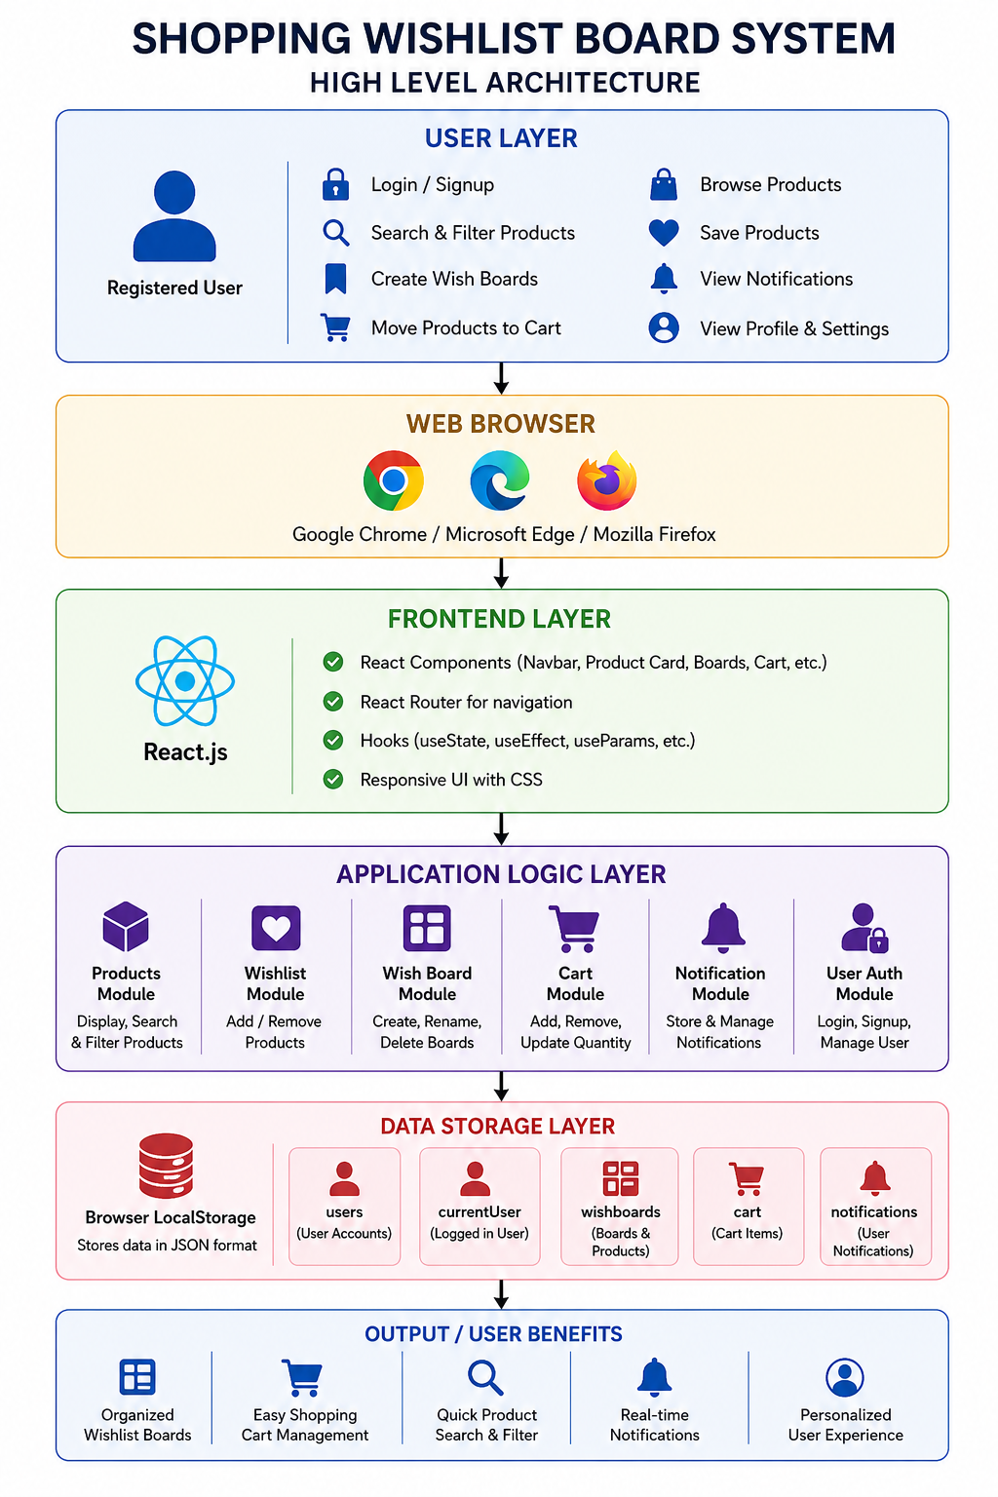

4.2 Description of Each Layer (Frontend, Backend, Database)

Frontend Layer
The Frontend Layer is the user interface of the Shopping Wishlist Board System, allowing users to interact with the application through a simple and responsive web interface. It is developed using React.js, HTML, CSS, and JavaScript, providing a dynamic and interactive user experience.
The frontend includes modules such as User Authentication, Product Browsing, Search & Filter, Wishlist Boards, Cart Management, and Notifications. Users can browse products, create and manage wish boards, move items to the cart, and receive activity notifications through an intuitive interface.
React components are used to build reusable UI elements, React Router enables smooth navigation between pages, CSS ensures a responsive design, and JavaScript handles user interactions, form validation, filtering, and state management. Overall, the frontend provides a clean, user-friendly, and efficient shopping experience.
Backend Layer
The Backend Layer manages the core functionality and business logic of the Shopping Wishlist Board System. It acts as the processing layer between the user interface and the browser's LocalStorage, handling data operations and application workflows.
The backend includes functional modules such as User Authentication, Product Management, Wishlist Management, Wish Board Management, Cart Management, Search & Filter, and Notification Management. It validates user actions, manages wishlist boards, updates cart items and quantities, processes product searches, and generates notifications for user activities.
In the current implementation, the backend logic is developed using JavaScript, with LocalStorage serving as the data storage mechanism. All user data, wishlist boards, cart items, and notifications are stored and retrieved in JSON format. In future versions, the application can be integrated with technologies such as Node.js, Express.js, and MySQL or MongoDB to support secure authentication, cloud storage, and large-scale deployment.
Database Layer
The Database Layer is responsible for storing, retrieving, updating, and managing all application data used by the Shopping Wishlist Board System. In the current implementation, the project uses Browser LocalStorage to persist data, allowing user information to remain available even after the browser is refreshed or reopened.
The database stores information such as User Accounts, Current User Details, Product Wishlist Boards, Saved Products, Shopping Cart Items, Cart Quantities, and Notifications. Whenever a user creates a board, saves a product, moves an item to the cart, or receives a notification, the data is stored and updated in LocalStorage using JSON format.
Although LocalStorage is sufficient for development and demonstration purposes, future versions of the application can integrate databases such as MySQL, MongoDB, or PostgreSQL to provide centralized storage, enhanced security, better scalability, automatic backups, and support for multiple users. The database layer ensures reliable data management and a consistent shopping experience throughout the application.

4.2 Deployment Architecture (Cloud, Local, CI/CD Pipelines)

The Deployment Architecture of the Shopping Wishlist Board System defines how the application is developed, tested, and deployed to provide a smooth and reliable user experience. The system is designed as a lightweight React-based web application, making it easy to develop, maintain, and scale.
During development, the application runs locally using React (Vite/Create React App) and stores data in the browser's LocalStorage for persistent storage. For deployment, the application can be hosted on platforms such as Vercel, Netlify, or GitHub Pages, allowing users to access it through any modern web browser. The project also supports Git and GitHub for version control and can be integrated with CI/CD pipelines to automate testing and deployment. This architecture ensures that the application remains reliable, accessible, and ready for future enhancements such as backend integration and cloud-based databases.

4.2.1 Local Deployment Architecture
Local Deployment is used during the development and testing phase of the Shopping Wishlist Board System. In this environment, the application runs on the developer's local machine without requiring a backend server or internet connection. The React application is executed using a local development server, while all user data such as accounts, wishlist boards, cart items, and notifications are stored in the browser's LocalStorage.
Local deployment enables developers to quickly test features, debug issues, and verify application functionality before deploying it to a live hosting platform.
Typical Local Environment:
- Developer Computer
- React Development Server (Vite/Create React App)
- Modern Web Browser (Chrome, Edge, Firefox)
- Browser LocalStorage
- Git & GitHub for Version Control
Local deployment provides a fast, cost-effective, and efficient environment for building and testing the application before production deployment.

4.2.2 Cloud Deployment Architecture
Cloud deployment enables the Shopping Wishlist System to be accessed securely from anywhere through the internet. The frontend application is hosted on cloud platforms such as Netlify, Vercel, AWS, Azure, or Google Cloud Platform, allowing users to access the system using any modern web browser. In future implementations, the application can be integrated with cloud databases like MongoDB Atlas or MySQL for centralized and secure data storage.
This deployment model provides high availability, scalability, improved security, automatic backups, and reliable performance. It supports multiple users simultaneously, making the system suitable for hospitals, transplant centers, administrators, and donors across different locations. Cloud deployment also enables easier maintenance, monitoring, and future expansion of the platform.
Cloud Components:
- Frontend Hosting (Netlify/Vercel/AWS/Azure)
- Cloud Database (MongoDB Atlas/MySQL)
- Authentication Services
- Notification Services (Email/SMS)
- Monitoring & Logging
- Backup & Recovery System

4.2.3 CI/CD Pipeline Architecture
The CI/CD (Continuous Integration and Continuous Deployment) Pipeline automates the process of building, testing, and deploying the OrganLink Registry System. Developers push code changes to a GitHub repository, which triggers automated workflows to validate the code, run tests, and build the application. Once all checks are successfully completed, the latest version is automatically deployed to the cloud hosting platform.
This automated pipeline reduces manual effort, minimizes deployment errors, improves code quality, and enables faster and more reliable software releases. It also supports continuous updates, quick bug fixes, and seamless delivery of new features.
Typical CI/CD Workflow:
Developer → GitHub Repository → Automated Build & Testing → Deployment → Production Server
Tools Used:
- Git & GitHub
- GitHub Actions
- Jenkins (optional)
- Docker (future deployment)
- Netlify / Vercel Deployment Pipeline

The deployment architecture ensures that the GiveLife – Organ Donor Registry Portal remains efficient, maintainable, scalable, and ready for future enhancements while supporting reliable access for all users.

CHAPTER -5 DESIGN

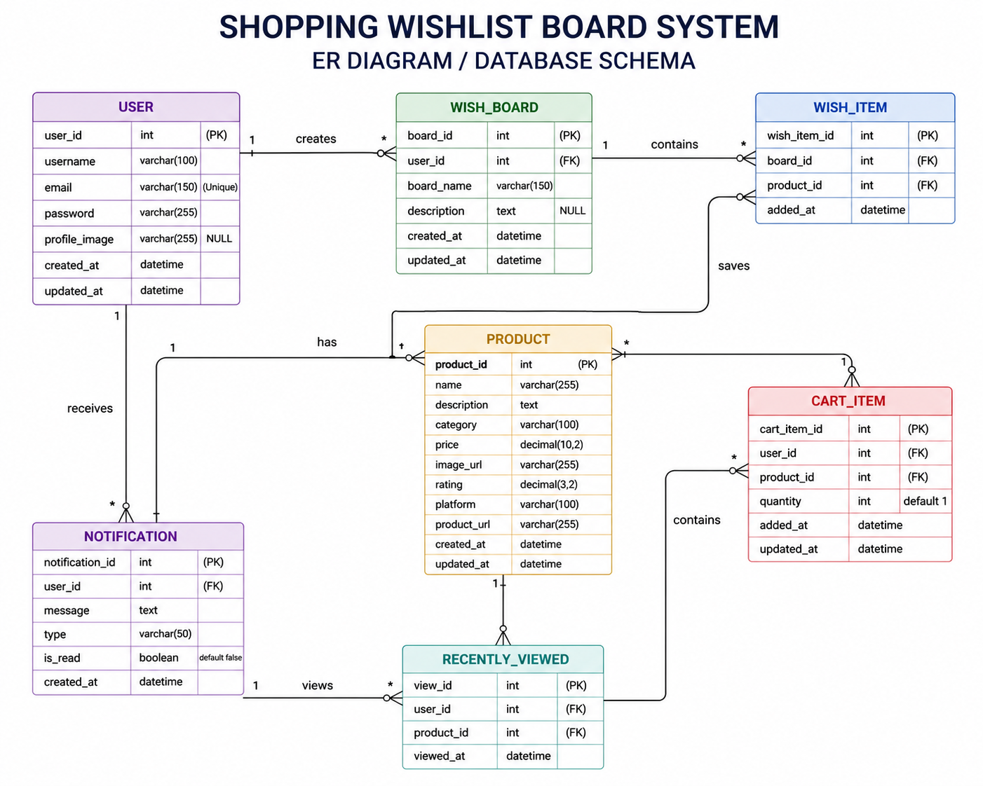

CHAPTER -6 IMPLEMENTATION

Section 6.1 – Module-Wise Implementation

1. User Authentication Module
The User Authentication Module serves as the entry point of the Shopping Wishlist Board System and provides a secure environment for every user. It manages user registration, login, logout, and session handling while ensuring that each user's personal information and shopping data remain private. The module allows new users to create an account by providing basic details such as name, email address, and password. Existing users can log in using their registered credentials to access their personalized shopping workspace.
The system verifies user credentials before granting access and stores authenticated user information using the browser's LocalStorage, allowing users to remain logged in during subsequent visits. After successful authentication, users can create wishboards, manage shopping carts, save products, and receive personalized notifications. Navigation is dynamically updated based on the user's login status, providing quick access to account-related features.
The frontend is built using React.js, while React Router manages navigation between authentication pages and other modules. Input validation ensures that required fields are completed correctly before processing user requests. Overall, this module provides a secure, user-friendly, and personalized foundation for the entire application.

2. Product Management Module
The Product Management Module is responsible for organizing, displaying, and managing all products available within the Shopping Wishlist Board System. It provides users with an attractive and interactive product catalog where each item is presented using reusable React components containing product images, names, prices, ratings, categories, and descriptions.
The module includes powerful search and filtering functionalities that allow users to locate products quickly based on product names, categories, and shopping platforms. Individual product pages display detailed product information, enabling users to make informed purchasing decisions before saving products to their wishboards or shopping cart.
A Recently Viewed Products feature records products that users have recently explored, allowing them to revisit previously viewed items conveniently. React state management ensures that product listings update dynamically without requiring page refreshes, creating a smooth browsing experience. The Product Management Module improves product organization, accessibility, and overall shopping convenience.

3. Wishlist Management Module
The Wishlist Management Module is the core functionality of the Shopping Wishlist Board System. It allows users to organize products into multiple personalized wishboards, similar to Pinterest boards, making it easier to categorize products according to their preferences such as Fashion, Electronics, Home Decor, or Gift Ideas.
Users can create unlimited wishboards, rename existing boards, delete unnecessary boards, and save products directly into selected boards. Products can also be removed from wishboards whenever users no longer wish to keep them. The module maintains all wishboard information using LocalStorage, ensuring that saved products remain available even after the browser is closed.
Each wishboard displays saved products with images, prices, and ratings, allowing users to manage their collections efficiently. Users also have the option to move products directly from a wishboard into the shopping cart without losing product information. React Hooks such as useState and useEffect are used extensively to manage board creation, updates, and synchronization. This module significantly improves shopping organization and encourages users to plan future purchases more effectively.

4. Cart Management Module
The Cart Management Module manages all shopping cart operations and represents the final stage before product purchase. Users can transfer products directly from their wishboards into the shopping cart, where selected items are displayed with complete product information including images, prices, quantities, and subtotal calculations.
The module allows users to increase or decrease product quantities, remove unwanted products, and automatically calculate the total cost of all selected items. Duplicate entries are prevented by updating product quantities instead of creating multiple identical records. Cart data is securely stored using LocalStorage, allowing users to continue shopping without losing previously selected products.
Synchronization between the wishlist and cart ensures that products moved into the cart are removed from the corresponding wishboard, preventing duplicate management while maintaining data consistency. React state management enables instant updates to quantities and total prices without requiring page reloads. This module provides users with a seamless, organized, and efficient shopping experience.

5. Notification & Alert Module
The Notification & Alert Module enhances user engagement by keeping shoppers informed about important activities occurring within the application. It maintains a personalized notification center that records significant events such as product additions to wishboards, products moved to the shopping cart, board creation, item removal, and other shopping-related activities.
Notifications are generated automatically whenever users perform important actions within the system. Each notification includes a message, timestamp, and read/unread status, allowing users to easily track recent activities. Users can mark all notifications as read or clear their notification history whenever desired.
The module is implemented using React state management together with LocalStorage, ensuring that notifications persist across browser sessions while updating dynamically as new activities occur. Future enhancements may include real-time price drop alerts, stock availability notifications, promotional offers, email notifications, and push notifications through cloud messaging services. By providing timely updates and personalized alerts, this module improves user interaction, shopping awareness, and the overall user experience.

Section 6.2 – Front-End Logic (UI Rendering and State Management)

The front-end logic of the Shopping Wishlist Board System is responsible for handling user interactions, rendering the user interface, and managing the application's data throughout different modules. Developed using React.js, HTML, CSS, and JavaScript, the frontend provides a responsive and interactive shopping experience. It acts as the communication layer between users and the browser's LocalStorage, ensuring that product information, wishboards, cart items, and notifications are updated dynamically without requiring page refreshes.
UI rendering refers to the process of displaying and updating the application's interface whenever user actions occur. In the Shopping Wishlist Board System, various interface components such as product cards, search results, wishlist boards, shopping cart, notifications, and user profile information are rendered dynamically using React components. Instead of reloading the entire webpage, React updates only the affected components, resulting in faster performance, smoother navigation, and an improved user experience.
When users browse products, apply search filters, create wishboards, save products, or move items to the cart, the interface updates instantly to reflect these changes. For example, when a new wishboard is created, it immediately appears on the Wishboards page. Similarly, when a product is added to a wishboard or moved to the shopping cart, the corresponding product lists are automatically updated without refreshing the browser. These real-time updates provide users with an efficient and seamless shopping experience.
State management is another essential aspect of the application's frontend. The application's state represents the current information maintained during execution, including user details, product listings, selected filters, wishlist boards, saved products, shopping cart items, notifications, and recently viewed products. React manages this data using useState and useEffect hooks, allowing the interface to react automatically whenever the application state changes.
The application also utilizes LocalStorage to persist data across browser sessions. User accounts, wishlist boards, cart information, notifications, and recently viewed products are stored in JSON format. Whenever users perform operations such as creating a board, saving a product, updating cart quantities, or clearing notifications, the application updates both the React state and LocalStorage, ensuring that data remains available even after the browser is closed or refreshed.
The search and filtering functionality also relies on state management. Users can search products by name and filter them based on category or shopping platform. As users type or select filter options, the displayed product list updates dynamically while the original product dataset remains unchanged. This provides fast and efficient product discovery without affecting stored data.
The Notification Module is another example of dynamic UI rendering. Whenever users perform important actions such as creating a wishboard, saving a product, moving an item to the cart, or removing a product, notification messages are generated automatically. Users can view these notifications, mark them as read, or clear them entirely, with all updates reflected instantly in the interface.
Overall, the Front-End Logic of the Shopping Wishlist Board System provides a smooth, responsive, and interactive user experience. Through efficient UI rendering, React state management, and LocalStorage integration, the application delivers real-time updates, maintains data consistency, and ensures seamless navigation across all modules. These features significantly improve usability, performance, and the overall shopping experience.

6.3 API Integration
API (Application Programming Interface) integration is an important aspect of modern web application development because it enables communication between web applications and external services. In the Shopping Wishlist Board System, API integration enhances the application's functionality, improves the user experience, and provides opportunities for future scalability. Although the current version of the application is developed using React.js, JavaScript, and LocalStorage, the system architecture is designed to support integration with various third-party APIs and cloud services as the application grows.
The primary purpose of API integration in the Shopping Wishlist Board System is to enable seamless communication between the application and external platforms. APIs allow the application to retrieve product information, authenticate users, send notifications, and synchronize data without exposing the application's internal implementation. This makes the system more dynamic, efficient, and capable of supporting real-world e-commerce functionalities.
One of the most valuable future integrations is with e-commerce product APIs provided by platforms such as Amazon, Flipkart, or other online marketplaces. These APIs can be used to fetch live product information, including product names, prices, ratings, images, availability, and product links. Instead of relying on static product data, the application would automatically display updated product information, ensuring that users always view the latest details.
The application can also integrate with authentication APIs such as Firebase Authentication, Google Sign-In, or OAuth. These services would allow users to log in securely using their Google or social media accounts, eliminating the need for manual account creation while improving security and user convenience.
Email service APIs such as EmailJS, SendGrid, or SMTP-based services can be integrated to automate communication with users. These APIs can send welcome emails after registration, notifications when wishboards are created, reminders about saved products, promotional offers, and shopping recommendations. Automated email communication helps increase user engagement and improves the overall shopping experience.
The system can further integrate with SMS and Push Notification APIs such as Twilio, Firebase Cloud Messaging (FCM), or OneSignal. These services can deliver instant alerts regarding price drops, product restocking, special discounts, wishlist updates, and promotional campaigns directly to users' mobile devices or web browsers. Real-time notifications encourage users to revisit the application and make timely purchasing decisions.
Cloud service APIs such as Firebase, MongoDB Atlas, Amazon Web Services (AWS), Microsoft Azure, or Google Cloud Platform can also be integrated in future versions. These services provide secure cloud databases, centralized storage, automatic backups, and scalable infrastructure. Cloud integration would allow users to access their wishboards, shopping carts, and notifications across multiple devices while ensuring data security and reliability.
Payment gateway APIs such as Razorpay, Stripe, or PayPal can be incorporated if the application evolves into a complete online shopping platform. These services enable secure online transactions, allowing users to purchase products directly from the application while ensuring safe and reliable payment processing.
Another useful integration is with Google Maps API, which can help users locate nearby physical stores, pickup locations, or partner retailers selling selected products. This feature improves accessibility and provides additional shopping convenience for users who prefer offline purchases.
In conclusion, API integration greatly enhances the functionality, scalability, and user experience of the Shopping Wishlist Board System. Through integration with product APIs, authentication services, email and notification providers, cloud platforms, payment gateways, and location-based services, the application can evolve into a comprehensive and intelligent shopping assistant. These integrations improve automation, real-time data synchronization, security, and user engagement, making the system more efficient and future-ready.

6.4 Authentication and Authorisation
Authentication and authorization are essential security components of the Shopping Wishlist Board System. Since the application manages user accounts, wishlist boards, shopping carts, and personalized notifications, it is important to ensure that only authorized users can access and manage their own data. These security mechanisms protect user privacy, maintain data integrity, and provide a safe and personalized shopping experience. Without proper authentication and authorization, unauthorized users could gain access to another user's wishboards, cart items, or personal information.
Authentication is the process of verifying the identity of a user before allowing access to the application. It answers the question, "Who is the user attempting to access the system?" In the current implementation, users register by providing their name, email address, and password. During login, the system validates the entered credentials against the user records stored in LocalStorage. Only users with valid credentials are allowed to log in and access their personalized shopping dashboard. After successful authentication, the logged-in user's information is stored in LocalStorage, allowing the application to maintain the user's session while navigating between different pages.
To improve security in future versions, advanced authentication methods such as Google Sign-In, Firebase Authentication, OAuth, Email Verification, One-Time Passwords (OTP), and Multi-Factor Authentication (MFA) can be integrated. These features provide additional protection by verifying user identity through multiple authentication methods, significantly reducing the risk of unauthorized access.
Authorization determines what an authenticated user is allowed to access and perform within the application. While authentication confirms the user's identity, authorization controls access to application features and data. After logging in, each user can only view and manage their own profile, wishboards, shopping cart, notifications, and recently viewed products. The application uses the logged-in user's email address as a unique identifier to separate user-specific data stored in LocalStorage, ensuring that one user cannot access another user's information.
The application follows a simple Role-Based Access Control (RBAC) approach, which can be expanded in future versions. Currently, all registered users have access to standard shopping features such as browsing products, creating wishboards, saving products, managing carts, and viewing notifications. Future enhancements may introduce an Administrator role with additional permissions to manage product catalogs, user accounts, promotional offers, and system settings, while regular users continue to access only their personal shopping data.
Session management is another important aspect of the application's security. Once users log in successfully, their session is maintained by storing the current user's information in LocalStorage. This allows users to navigate across different pages without logging in repeatedly. When users log out, the stored session information is removed, preventing unauthorized access to their account from the same device.
Password protection can also be enhanced in future versions by implementing password hashing and encryption instead of storing passwords directly. Authentication services such as Firebase Authentication or secure backend APIs can provide encrypted password storage, secure token-based authentication, and stronger protection against security threats.
In conclusion, authentication and authorization play a vital role in securing the Shopping Wishlist Board System. Authentication verifies user identities, while authorization ensures that users can only access their own shopping data and application features. Together, these mechanisms protect user information, prevent unauthorized access, and provide a secure, reliable, and personalized shopping experience. The application's architecture also supports future integration with advanced authentication services and role-based security models, making it scalable and ready for real-world deployment.

CHAPTER -7 FEATURES

7.1 List of Main Features
The ShopWish – Wishlist Aggregation and Shopping Management System is a modern web-based application designed to help users organize products from different shopping platforms, manage personalized wishlists, track shopping activities, and improve their overall online shopping experience. The system combines product discovery, Pinterest-style wishboards, cart management, and notifications into a single user-friendly platform. The major features of the application are described below.

1. User Registration and Login
The system provides a secure authentication module where users can create an account and log in using their email address and password. User sessions are maintained using LocalStorage, allowing users to access their personalized data such as wishboards, cart items, and notifications after logging in.

2. Product Browsing and Exploration
Users can explore a collection of products displayed with product images, names, prices, ratings, categories, and shopping platform details. The product catalog is organized using reusable React components to provide a clean and consistent shopping interface.

3. Product Search and Filtering
The application includes powerful search and filtering features that allow users to quickly find products based on product names, categories, and shopping websites such as Amazon, Flipkart, Myntra, and Littlebox. The product list updates dynamically as users apply filters.

4. Product Details Page
Each product has a dedicated details page displaying complete information such as description, rating, price, shopping platform, and a direct product link. This allows users to make informed decisions before saving products to their wishboards.

5. Recently Viewed Products
The system automatically tracks products viewed by users and displays them in a Recently Viewed section. This feature helps users revisit products they explored earlier without searching again.

6. Pinterest-Style Wishboards
This is the core feature of the application. Users can create multiple personalized wishboards similar to Pinterest boards, organize products into different categories, rename boards, delete boards, and manage saved products efficiently.

7. Save Products to Wishboards
Users can save products directly from the product details page into any selected wishboard. Duplicate entries are prevented automatically, ensuring that the same product is not saved multiple times in a board.

8. Remove Products from Wishboards
Products can be removed from wishboards whenever users no longer wish to keep them. The interface updates instantly and synchronizes the changes with LocalStorage.

9. Move Products to Cart
Users can transfer products directly from a wishboard to the shopping cart. This feature acts as a “Save for Later” workflow, allowing users to move selected items closer to the purchasing stage.

10. Shopping Cart Management
The cart module displays all selected products along with their quantities, prices, and subtotals. Users can increase or decrease quantities, remove items, and view the total cart value dynamically.

11. Cart and Wishlist Synchronization
When a product is moved from a wishboard to the cart, it is automatically removed from the corresponding board. This prevents duplicate management and maintains data consistency throughout the application.

12. Notification Center
The application includes a personalized notification system that records important user activities such as product saves, cart additions, board creation, and product removals. Notifications are stored persistently and can be marked as read or cleared.

13. Dynamic User Interface
All modules update dynamically without requiring page refreshes. React state management ensures that changes such as board creation, cart updates, and notification additions are reflected instantly across the interface.

14. LocalStorage-Based Data Persistence
The current implementation uses browser LocalStorage to store user accounts, wishboards, cart items, notifications, and recently viewed products. This allows data to persist even after the browser is closed and reopened.

15. Responsive and User-Friendly Design
The application is designed with a clean, modern, and responsive interface that works across desktops, laptops, tablets, and mobile devices. Clear navigation and intuitive layouts make the system easy to use for all users.

16. Future Enhancement Support
The architecture is designed to support future integration with cloud databases, real-time price tracking APIs, browser extensions for wishlist aggregation, AI-powered product recommendations, email and push notifications, and secure backend authentication systems.
In conclusion, the ShopWish – Wishlist Aggregation and Shopping Management System combines product exploration, personalized wishboards, shopping cart management, notifications, and dynamic user interaction into a single integrated platform. These features work together to simplify shopping organization, improve user engagement, and provide a modern and efficient online shopping experience.

7.2 HOW DOES IT WORK?
The ShopWish application is a web-based e-commerce wishlist management system developed to help users organize products they intend to purchase in the future. The application provides a centralized platform where users can browse products, save items to personalized wishlists, manage shopping carts, and receive notifications about product updates. By combining product management, wishlist organization, cart operations, and user account management, ShopWish offers a convenient and user-friendly shopping experience.
The workflow begins when a user visits the ShopWish application and creates an account or logs into an existing account through the User Authentication Module. The system verifies the user's credentials and grants secure access to personalized features such as wishlists, shopping cart, notifications, and profile management. Authentication ensures that each user's shopping data remains private and securely stored.
After logging in, users can browse the Product Catalog, where products are displayed with images, names, prices, ratings, descriptions, and categories. Products are organized using reusable React components, making the interface responsive and visually appealing. Users can search for products using keywords or apply filters based on categories, price ranges, ratings, or brands to quickly locate desired items.
When users find products they are interested in, they can add them to their Wishlist with a single click. The Wishlist Management Module allows users to create multiple wishlists for different purposes, such as electronics, fashion, books, or gifts. Each saved product remains stored in the user's wishlist until it is purchased or removed. Wishlist data is managed using React state management and browser LocalStorage, allowing products to remain available even after the browser is closed and reopened.
The application also provides a "Save for Later" feature that allows users to move products between the shopping cart and wishlist whenever needed. This flexibility enables shoppers to organize purchases according to their priorities while avoiding the need to repeatedly search for products.
When users decide to purchase an item, they can transfer products from the wishlist to the Shopping Cart. The Cart Management Module handles all cart-related operations, including adding products, updating quantities, removing unwanted items, and calculating the total price. The system continuously synchronizes cart and wishlist data to ensure that products are accurately managed without duplication or data inconsistency.
Throughout the shopping process, the Notification & Alert Module keeps users informed about important activities. Notifications are generated whenever products are added to or removed from the wishlist, moved to the cart, or when prices change and products become available. These real-time alerts provide immediate feedback and help users stay updated on their shopping activities.
The application also maintains a Recently Viewed Products section that displays items recently explored by the user. This feature makes it easier for users to revisit products without performing another search, thereby improving the overall shopping experience.
React's state management plays a crucial role in ensuring that all user interactions are reflected immediately throughout the application. Whenever users add items to their wishlist, update the cart, remove products, or modify their profile information, the interface updates dynamically without requiring a page refresh. This creates a smooth, responsive, and interactive user experience.
The application stores essential user information, wishlist items, shopping cart data, and notification history using browser LocalStorage in the current implementation. This lightweight storage solution allows data to persist between sessions without requiring a backend database. In future versions, LocalStorage can be replaced with cloud-based databases such as MongoDB or Firebase to support multiple users, secure authentication, and real-time synchronization across devices.
Overall, ShopWish operates through a series of interconnected modules including user authentication, product browsing, wishlist management, shopping cart operations, notification handling, and state management. Each module works together to provide a seamless shopping experience, allowing users to organize products, manage future purchases, and track their shopping preferences efficiently. By simplifying product organization and improving shopping convenience, ShopWish serves as a practical and user-friendly wishlist management platform for modern online shoppers.

CHAPTER -8 TESTING

8.1 Postman Testing (Frontend/Backend)
Postman Testing is an important part of the software testing process that helps verify the communication between the frontend and backend of the ShopWish – Wishlist Management System. It ensures that all API requests related to user authentication, product management, wishlist operations, cart management, and notifications function correctly and return the expected responses. Postman was used to validate API endpoints, test request and response handling, and confirm that data is processed accurately before being displayed on the user interface.
The testing process began by creating API requests for the core functionalities of the application. Various HTTP methods such as GET, POST, PUT, PATCH, and DELETE were used to test different operations. POST requests were used for user registration, user login, adding products to the wishlist, adding items to the cart, and generating notifications. These requests contained information such as user credentials, product IDs, wishlist details, and cart information. The backend validated the incoming data and returned appropriate success responses upon successful completion of each operation.
GET requests were used to retrieve application data from the backend. These requests fetched product listings, wishlist items, cart contents, user profile information, and notification history. The responses were verified to ensure that the correct data was returned in JSON format and displayed accurately on the frontend. Product information such as product name, image, price, category, rating, and availability was checked for consistency across different modules of the application.
PUT and PATCH requests were used to test update operations. These included updating user profile information, modifying wishlist names, changing product quantities in the cart, marking notifications as read, and updating account settings. After each update request, additional GET requests were executed to verify that the changes were successfully reflected in the database and displayed correctly on the frontend interface.
DELETE requests were performed to test removal operations within the application. Products were removed from wishlists and shopping carts, notifications were cleared, and user data was deleted where applicable. The backend successfully removed the requested records, and subsequent retrieval requests confirmed that the deleted information was no longer available. This testing ensured that deletion operations worked correctly without affecting unrelated application data.
The Wishlist Management Module, which is the core functionality of ShopWish, was extensively tested using Postman. API endpoints responsible for creating wishlists, adding products, removing products, moving items between the wishlist and shopping cart, and retrieving saved products were validated. The responses were compared with expected outputs to ensure that wishlist operations maintained data consistency and synchronization with the frontend interface.
The Cart Management Module was also thoroughly tested. API requests verified product addition, quantity updates, item removal, total price calculation, and synchronization between the wishlist and cart. The backend correctly processed all requests, and the frontend accurately reflected the updated cart information after each operation.
Testing was also performed for the Notification Module. Notification APIs were validated to ensure that users received alerts for important activities such as successful login, wishlist updates, cart modifications, product availability changes, and price drop notifications. The notification data was retrieved successfully and displayed dynamically within the application.
Error handling formed another important aspect of Postman testing. Invalid requests containing incorrect login credentials, missing required fields, duplicate user registrations, invalid product IDs, unauthorized access attempts, and malformed JSON data were intentionally submitted. The backend generated appropriate error messages and returned suitable HTTP status codes, confirming that input validation and exception handling mechanisms were functioning correctly.
Response validation was performed by checking HTTP status codes such as 200 (OK), 201 (Created), 400 (Bad Request), 401 (Unauthorized), 404 (Not Found), and 500 (Internal Server Error) wherever applicable. The response body was examined to verify that returned data matched the expected JSON structure and contained accurate information. Response times were also monitored to ensure efficient communication between the frontend and backend services.
Overall, Postman testing played a significant role in validating the functionality, reliability, and performance of the ShopWish – Wishlist Management System. By thoroughly testing user authentication, product management, wishlist operations, cart management, notifications, data validation, and error handling, the application was verified to provide secure and seamless communication between the frontend and backend. This comprehensive testing process helped ensure that ShopWish delivers a reliable, efficient, and user-friendly shopping experience.

8.2 Integration Testing
Integration Testing is performed to verify that the various modules of the ShopWish – Smart Wishlist & Product Management System work together correctly and exchange information without errors. Since the application consists of multiple interconnected modules such as User Authentication, Product Management, Wishlist Management, Cart Management, and Notification Management, integration testing ensures smooth communication between these components. The primary objective is to validate that data flows correctly across modules and that all features function as a unified system.
The first integration test focused on the interaction between the User Authentication Module and the Wishlist Management Module. After a user successfully logged into the application, the system was expected to load the user's saved wishlists and recently viewed products automatically. Testing confirmed that authenticated users could access only their own wishlist data and that all previously saved items were displayed correctly.
The integration between the Product Management Module and the Wishlist Module was also thoroughly tested. When users browsed products and selected the "Add to Wishlist" option, the selected products were immediately stored in the wishlist and displayed without requiring a page refresh. Any changes made to product details, such as updated prices or product availability, were also reflected within the wishlist, ensuring data consistency across the application.
Another important integration test involved the Wishlist Management Module and the Cart Management Module. Users were able to move products directly from the wishlist to the shopping cart using the "Move to Cart" feature. After the transfer, the product was successfully added to the cart and removed from the wishlist, preventing duplicate entries. The synchronization between these two modules ensured a seamless shopping experience.
The Cart Management Module was further integrated with the Product Management Module to verify accurate product information and pricing. Whenever users updated product quantities or removed items from the cart, the total price and item count were automatically recalculated and displayed correctly. This confirmed proper communication between product data and cart operations.
The Notification & Alert Module was tested with all major system activities. Notifications were generated whenever users added or removed products from the wishlist, moved items to the cart, updated product quantities, or performed login and logout operations. The application successfully displayed real-time confirmation and error messages, improving user awareness and providing immediate feedback for every important action.
The integration between the Wishlist Module and Local Storage was also verified. Products added to the wishlist remained available even after refreshing the browser or reopening the application. Similarly, cart contents, recently viewed products, and notifications were restored correctly from Local Storage, demonstrating reliable data persistence throughout the application.
Performance and reliability were evaluated by performing multiple operations consecutively, including logging in, browsing products, adding items to wishlists, moving products to the cart, updating quantities, and removing items. Throughout these operations, the application maintained stable performance, synchronized data accurately, and updated the user interface dynamically without delays or inconsistencies.
In conclusion, the integration testing of the ShopWish – Smart Wishlist & Product Management System confirmed that all major modules functioned together as a single, well-coordinated application. The successful interaction between authentication, product management, wishlist management, cart management, notifications, and Local Storage ensured data consistency, smooth user experience, and reliable system performance. These results demonstrate that the integrated system is efficient, dependable, and capable of supporting users throughout their online shopping journey.

8.3 Tools Used for Testing

1. Google Chrome Developer Tools
Google Chrome Developer Tools (Chrome DevTools) was the primary testing tool used during the development of the ShopWish – Smart Wishlist & Product Management System. It helped inspect HTML elements, debug JavaScript code, monitor browser storage, and identify UI-related issues. The Console tab was used to detect JavaScript errors, while the Application tab allowed developers to verify LocalStorage data such as wishlist items, cart data, user information, and notifications. DevTools also supported responsive design testing across different screen sizes, ensuring the application functioned correctly on desktops, tablets, and mobile devices.

2. React Developer Tools
React Developer Tools is a browser extension specifically designed for React applications. It was used to inspect React components, monitor component hierarchy, analyze props and state values, and debug component rendering. This tool helped verify that Wishlist, Cart, Product, Authentication, and Notification components updated correctly whenever users performed actions such as adding products to the wishlist or moving items to the cart.

3. Selenium WebDriver
Selenium WebDriver is an automated browser testing framework used to simulate real user interactions with web applications. In the ShopWish project, Selenium can be used to automate testing of user registration, login, product browsing, wishlist management, cart operations, and notification functionality. Automated browser testing reduces manual effort and ensures that the application behaves consistently across different browsers.

4. Apache JMeter
Apache JMeter is a performance testing tool used to evaluate how an application performs under different user loads. For ShopWish, JMeter can simulate multiple users browsing products, adding items to wishlists, and managing shopping carts simultaneously. It measures response time, throughput, and system stability, helping developers identify performance bottlenecks and optimize the application's efficiency.

5. Git and GitHub
Git is a distributed version control system used to track source code changes, while GitHub provides cloud-based repository hosting. Throughout the development of ShopWish, Git and GitHub were used to manage project versions, maintain code history, and collaborate efficiently. They also served as backup systems, allowing developers to restore previous versions whenever required.

6. GitHub Actions
GitHub Actions provides automated Continuous Integration (CI) workflows directly within GitHub. It can automatically build the React application, run code quality checks, and verify that the project compiles successfully whenever new code is pushed to the repository. This automation improves software quality and reduces deployment errors.

7. Jira / GitHub Issues
Jira and GitHub Issues are project management and bug-tracking tools used to record software defects, assign development tasks, and monitor project progress. These tools help organize feature development, prioritize bugs, and improve collaboration among team members throughout the software development lifecycle.

8. ESLint
ESLint is a static code analysis tool used to identify programming errors and maintain consistent coding standards throughout the React project. It detects syntax errors, unused variables, incorrect coding practices, and potential bugs before the application is executed, improving overall code quality and maintainability.

9. Google Lighthouse
Google Lighthouse is an automated web auditing tool used to evaluate website quality. It analyzes application performance, accessibility, SEO, responsiveness, and adherence to modern web development best practices. Lighthouse generates detailed reports with optimization recommendations, helping improve the speed, usability, and accessibility of the ShopWish application.

  - TEST CASES AND RESULTS

Testing was conducted on the ShopWish – Smart Wishlist & Product Management System to verify that all functionalities operate correctly and satisfy the specified system requirements. The test cases covered the major modules of the application, including User Authentication, Product Management, Wishlist Management, Cart Management, Notifications, and Local Storage. The objective of testing was to ensure system reliability, data consistency, usability, and correct operation under various user scenarios.

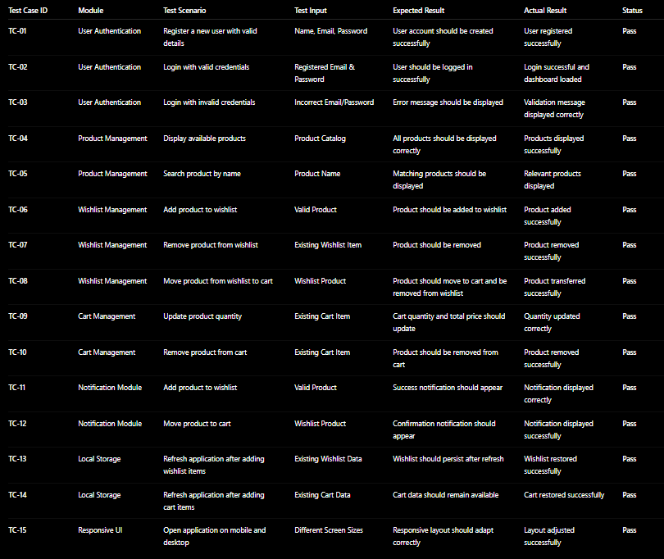

The testing results indicate that all major functionalities of the ShopWish – Smart Wishlist & Product Management System performed as expected. User authentication, product browsing, wishlist operations, cart management, notification handling, Local Storage persistence, and responsive user interface were successfully validated. All test cases passed without critical issues, confirming that the application is reliable, user-friendly, and capable of providing a smooth shopping experience across different devices and usage scenarios.

CHAPTER -9 DEPLOYMENT

9.1 Steps to Deploy
Deployment is the process of making the ShopWish – Smart Wishlist & Product Management System available to users through the internet. It is an important phase of the software development lifecycle because it transforms the developed application into a live, accessible, and fully functional web application. A successful deployment ensures that the application performs efficiently, remains secure, and provides a seamless shopping experience. For the ShopWish project, deployment involves preparing the project files, optimizing the application, selecting a hosting platform, and verifying that all features work correctly after deployment.
The deployment process begins after the completion of development and testing activities. Before deployment, all modules such as User Authentication, Product Management, Wishlist Management, Cart Management, Notification System, and Local Storage Integration are thoroughly tested to ensure they function correctly. Functional, integration, and performance testing are performed to identify and resolve any issues, ensuring the application is stable and ready for production.
The second step involves organizing the project resources and source code. All React components, HTML templates, CSS files, JavaScript files, images, icons, and other assets are structured properly within the project directory. Unused files, debugging code, and temporary resources are removed to improve maintainability, reduce application size, and enhance performance.
The third step is source code management using Git and GitHub. The complete ShopWish project is uploaded to a GitHub repository, allowing developers to maintain version history, track code changes, and collaborate efficiently. GitHub also serves as the primary source for deployment through hosting platforms such as Netlify, Vercel, or GitHub Pages.
The fourth step is configuring the production environment. Necessary project settings such as environment variables, application configuration, routing, and build settings are prepared for production. Since ShopWish uses browser-based Local Storage, no external database configuration is required in the current implementation, simplifying the deployment process.
The fifth step involves application optimization. The React application is built using production commands to generate optimized static files. Code minification, asset compression, image optimization, and caching techniques are applied to reduce loading times and improve overall application performance.
The sixth step is frontend deployment. The production build of the application is deployed to a hosting platform such as Netlify, Vercel, or GitHub Pages. These platforms provide secure HTTPS hosting, automatic deployments from GitHub, custom domain support, and high availability, making them ideal for React-based web applications.
After deployment, verification testing is performed in the live environment. All major functionalities—including user registration and login, product browsing, wishlist operations, cart management, notifications, search functionality, and responsive design—are tested to ensure they work correctly in the production environment. Any issues identified during verification are corrected before the application is released to end users.
Security is another important aspect of deployment. The application is served over HTTPS to ensure secure communication between users and the hosting server. Best practices such as input validation, secure coding standards, and dependency updates help improve application security and reliability.
For continuous development, Continuous Integration and Continuous Deployment (CI/CD) can be implemented using GitHub Actions or similar automation tools. Whenever developers push code changes to the GitHub repository, the application can be automatically built, tested, and redeployed. This reduces manual effort, minimizes deployment errors, and ensures that users always have access to the latest version of the application.
In conclusion, the deployment process transforms the ShopWish – Smart Wishlist & Product Management System into a live, accessible, and reliable web application. By following proper deployment practices, including testing, optimization, version control, secure hosting, and automated deployment, the application delivers a smooth, secure, and scalable shopping experience while remaining easy to maintain and enhance in the future.

9.2 Environment Configuration
Environment configuration refers to the setup of software tools, development frameworks, libraries, hosting platforms, and security settings required for the successful development and deployment of the ShopWish – Smart Wishlist & Product Management System. A well-configured environment ensures that the application runs consistently across development, testing, and production stages while maintaining reliability, performance, and scalability.
The frontend environment of ShopWish is built using React.js, HTML5, CSS3, and JavaScript (ES6+). React.js is used to develop reusable UI components and manage application state, HTML provides the structural layout of web pages, CSS is responsible for responsive styling and visual presentation, and JavaScript adds dynamic functionality and user interaction. Together, these technologies create an interactive, responsive, and user-friendly shopping experience.
Visual Studio Code serves as the primary development environment for the project. It provides features such as syntax highlighting, intelligent code completion, integrated terminal support, debugging tools, Git integration, and extension support. These capabilities enable developers to write, debug, and maintain the application efficiently.
Version control is configured using Git and GitHub. Git tracks all changes made to the project files, while GitHub hosts the remote repository and enables collaboration, version management, and secure backup of the source code. Developers can work using branches, merge updates through pull requests, and maintain a complete history of the project.
Since the current implementation is a frontend-based React application, no dedicated backend server is required. Application data such as user information, wishlist items, shopping cart data, and notifications are stored using the browser's Local Storage, providing persistent storage without requiring a database server. This simplifies the development and deployment process while ensuring that user data remains available even after refreshing or reopening the application.
The project dependencies and libraries are managed using Node.js and npm (Node Package Manager). Node.js provides the runtime environment required for React development, while
npm installs and manages packages such as React Router, React Icons, and other project dependencies. The development server is executed using npm commands, allowing developers to test the application locally before deployment.
Security configuration includes client-side input validation, secure coding practices, and HTTPS support provided by the hosting platform. User inputs are validated before processing to prevent invalid data entry, while production deployment ensures encrypted communication between users and the application through SSL certificates.
The hosting environment is configured using platforms such as Netlify, Vercel, or GitHub Pages. These platforms automatically build and deploy the React application from the GitHub repository, provide secure HTTPS hosting, support custom domains, and offer automatic deployment whenever code changes are pushed to the repository.
Performance optimization settings are also configured to improve the application's efficiency. React production builds perform code minification and optimization, while image compression, browser caching, and static asset optimization help reduce loading times and improve responsiveness across different devices and browsers.
For continuous development, GitHub Actions can be configured to implement Continuous Integration and Continuous Deployment (CI/CD). Automated workflows can build the application, verify successful compilation, and deploy updated versions whenever new code is committed, reducing manual effort and improving software quality.
Overall, the environment configuration of the ShopWish – Smart Wishlist & Product Management System provides a stable and efficient development ecosystem. Through the integration of React.js, Node.js, npm, Visual Studio Code, Git, GitHub, Local Storage, and modern hosting platforms, the application achieves high performance, maintainability, security, and scalability while remaining easy to develop, deploy, and enhance in the future.

9.3 Hosting of Frontend and Backend
Hosting is an essential phase in the deployment of the ShopWish – Smart Wishlist & Product Management System because it makes the application accessible to users over the internet. Proper hosting ensures that the application remains available, secure, responsive, and scalable while providing a smooth shopping experience. Since ShopWish is a React-based frontend application, hosting primarily involves deploying the user interface and static assets to a reliable cloud hosting platform.
The frontend of ShopWish is developed using React.js, HTML5, CSS3, and JavaScript. These technologies create an interactive interface through which users can register, log in, browse products, manage wishlists, add items to the shopping cart, and receive notifications. As the application consists of static files generated during the React build process, it can be hosted efficiently on platforms such as Netlify, Vercel, or GitHub Pages. These platforms provide secure HTTPS hosting, automatic deployment, fast content delivery, and support for custom domains.
The hosting process begins by uploading the complete project to a GitHub repository. The hosting platform is then connected to the repository. Whenever developers push updates to GitHub, the hosting platform automatically detects the changes, builds the latest version of the
React application, and deploys it. This Continuous Deployment process ensures that users always access the most recent version of ShopWish while reducing manual deployment effort and minimizing errors.
One of the key advantages of these hosting platforms is the use of Content Delivery Networks (CDNs). CDNs distribute copies of the application's static files across multiple servers worldwide, allowing users to load the application from the server closest to their location. This significantly improves page loading speed, reduces latency, and enhances the overall user experience.
The current version of ShopWish uses the browser's Local Storage to store user information, wishlist items, shopping cart data, and notifications. Since no external backend server or database is required, deployment is straightforward and cost-effective. In future versions, backend services and cloud databases such as Firebase, MongoDB Atlas, or Node.js with Express can be integrated to support user authentication, synchronized data storage, and multi-device access.
Security is an important aspect of hosting. Hosting providers automatically enable HTTPS using SSL certificates, ensuring secure communication between users and the application. Additional security measures such as input validation, secure coding practices, and regular dependency updates help protect the application from common security vulnerabilities.
Cloud hosting platforms also offer excellent reliability and availability. Features such as automatic deployments, high uptime, monitoring tools, and rollback capabilities ensure that the application remains accessible and stable. Administrators can monitor deployment status, application performance, and build logs directly from the hosting dashboard.
For future enhancements, Continuous Integration and Continuous Deployment (CI/CD) can be implemented using GitHub Actions, allowing every code update to be automatically tested, built, and deployed. This improves software quality, accelerates development, and ensures that new features are delivered efficiently.
In conclusion, hosting plays a vital role in the successful deployment of the ShopWish – Smart Wishlist & Product Management System. By hosting the application on platforms such as Netlify, Vercel, or GitHub Pages, ShopWish becomes easily accessible, secure, and highly reliable. Combined with GitHub integration, HTTPS security, CDN support, and automated deployment, the hosting environment provides a strong foundation for delivering a fast, scalable, and user-friendly shopping application while supporting future growth and enhancements.
9.3.1 Frontend Hosting
Frontend hosting refers to the process of deploying the ShopWish – Smart Wishlist & Product Management System so that users can access it through a web browser. The frontend is developed using React.js, HTML, CSS, and JavaScript, and includes pages such as Home, Login, Product Listing, Product Details, Wishlist, Cart, and User Profile.
The application consists of static files generated during the React build process, which are hosted on platforms such as Netlify, Vercel, or GitHub Pages. The project source code is stored in a GitHub repository, and the hosting platform automatically rebuilds and deploys the application whenever new changes are pushed, ensuring the live website always stays up to date.
Frontend hosting platforms use Content Delivery Networks (CDNs) to deliver content quickly from the nearest server, improving page loading speed and overall performance. They also provide HTTPS security, SSL certificates, custom domain support, and automatic deployment features to ensure a secure and reliable user experience.
Overall, frontend hosting makes ShopWish easily accessible, fast, secure, and responsive, allowing users to browse products, manage wishlists, and access shopping features from any device with an internet connection.
9.3.2 Backend Hosting
Backend hosting refers to the deployment of the server-side components that manage the application's business logic, user authentication, product management, wishlist operations, cart processing, notifications, and database communication. It ensures that all user requests are processed securely and efficiently behind the scenes.
The backend of ShopWish – Smart Wishlist & Product Management System can be developed using Node.js and Express.js, which handle requests from the frontend, validate user inputs, process business logic, and communicate with the database. Backend services can be hosted on cloud platforms such as Render, Railway, Heroku, AWS, or Microsoft Azure.
A cloud database such as MongoDB Atlas can be integrated to securely store user accounts, product information, wishlist data, shopping cart details, and notifications. The backend communicates with the database through secure connections to perform data storage and retrieval operations.
Backend hosting also provides essential security features such as HTTPS encryption, authentication and authorization, environment variables for protecting sensitive credentials, and monitoring tools for maintaining system performance and reliability.
Overall, backend hosting enables ShopWish to securely manage user data, process application requests, support future scalability, and provide a reliable shopping experience.

9.3.3 CI/CD Integration
CI/CD (Continuous Integration and Continuous Deployment) is an important practice that automates the process of building, testing, and deploying the ShopWish – Smart Wishlist & Product Management System. It ensures that new code changes are integrated, tested, and deployed efficiently while maintaining application stability.
Continuous Integration (CI) enables developers to regularly push code changes to a shared GitHub repository. Whenever new code is committed, automated workflows verify that core modules such as User Authentication, Product Management, Wishlist, Shopping Cart, and Notifications continue to function correctly. This helps identify bugs early and improves code quality.
Continuous Deployment (CD) automatically deploys the updated application to hosting platforms such as Netlify, Vercel, or Render after successful testing. This eliminates manual deployment, reduces errors, and ensures that users always access the latest version of ShopWish. Tools such as GitHub Actions or Jenkins can be used to automate the complete deployment pipeline.
Overall, CI/CD integration improves development efficiency, enhances collaboration, reduces deployment time, and ensures reliable, continuous delivery of new features and updates for the ShopWish – Smart Wishlist & Product Management System.

Monitoring and Performance Optimisation
Monitoring and Performance Optimisation are important activities carried out after deploying the ShopWish – Smart Wishlist & Product Management System to ensure that the application remains fast, reliable, and efficient. Monitoring involves continuously tracking the application's performance, availability, and overall health to identify issues such as slow page loading, broken features, or system errors before they impact users.
Various monitoring tools can be used to observe key metrics such as page load time, application uptime, response time, resource usage, and user activity. Error logs and performance reports help developers quickly identify and resolve issues, ensuring a smooth shopping experience.
Performance optimisation focuses on improving the speed and responsiveness of the application. Techniques such as image optimization, code minification, lazy loading, browser caching, and Content Delivery Networks (CDNs) are used to reduce loading times and enhance performance. Efficient React component rendering and optimized state management further improve the application's responsiveness.
For ShopWish, these optimisations ensure that product browsing, wishlist management, cart operations, and user interactions are executed quickly and efficiently. Regular monitoring and optimisation improve user satisfaction, reduce downtime, and ensure that the application remains scalable and performs reliably as the number of users and products grows.

Domain, Networking, and Global Access
Domain, Networking, and Global Access are important aspects of deploying the ShopWish – Smart Wishlist & Product Management System, ensuring that the application is secure, reliable, and accessible to users from anywhere. A custom domain name provides an easy-to-remember web address, such as www.shopwish.com, improving the platform's professionalism, branding, and user trust.
Networking enables seamless communication between the frontend, backend, and database. When users browse products, manage wishlists, or update their shopping cart, requests are securely transmitted between the client and server through the internet. Proper network configuration ensures fast, reliable, and uninterrupted communication across all application components.
To enhance security, the application uses HTTPS and SSL certificates to encrypt data
exchanged between users and the server. Additional security measures such as secure API communication, firewalls, and access controls help protect user accounts and shopping data from unauthorized access.
Global access is achieved through cloud hosting platforms and Content Delivery Networks (CDNs), which distribute application content across multiple servers worldwide. This reduces latency, improves loading speed, and provides a consistent user experience regardless of the user's location.
Overall, effective domain management, secure networking, and global accessibility ensure that ShopWish remains fast, secure, scalable, and available to users worldwide while supporting future growth and increasing user traffic.

Scaling, Backup, and Redundancy
Scaling, Backup, and Redundancy are important aspects of maintaining the ShopWish – Smart Wishlist & Product Management System after deployment. These practices ensure that the application remains reliable, secure, and capable of handling increasing numbers of users and products without affecting performance.
Scaling enables the application to support growing user traffic and data efficiently. As more users browse products, manage wishlists, and use shopping features, cloud hosting platforms such as AWS, Azure, Render, or Google Cloud can automatically allocate additional resources to maintain fast response times and smooth performance.
Backup involves creating regular copies of important data, including user accounts, product information, wishlists, shopping cart details, and order history. Automated cloud backups help prevent data loss caused by accidental deletion, hardware failures, or system issues, ensuring quick recovery whenever required.
Redundancy improves system availability by maintaining duplicate servers and replicated databases. If a primary server or database fails, a backup system automatically takes over, minimizing downtime and ensuring uninterrupted access for users.
Together, scaling, backup, and redundancy enhance the reliability, availability, and fault tolerance of ShopWish, ensuring continuous service, protecting valuable user data, and supporting the future growth of the platform.

Post-Deployment Verification and Maintenance
Post-Deployment Verification and Maintenance are essential activities performed after the ShopWish – Smart Wishlist & Product Management System is deployed. Their purpose is to ensure that the application functions correctly in the live environment and continues to provide a reliable and secure shopping experience.
After deployment, verification testing is conducted to confirm that all major modules, including User Authentication, Product Management, Wishlist, Shopping Cart, Notifications, and User Profiles, work as expected. Developers verify that users can register, log in, browse products, manage wishlists, add items to the cart, and receive notifications without errors. Any issues identified are resolved immediately to ensure smooth operation.
Maintenance is an ongoing process that includes bug fixes, performance improvements, security updates, and feature enhancements. Regular updates help keep the application stable, secure, and compatible with evolving technologies. If a backend database is used, routine database maintenance, backups, and optimization are also performed.
Developers continuously monitor application performance, page load times, server health, and error logs to detect and resolve issues quickly. User feedback is also reviewed to improve usability and introduce new features based on customer needs.
Regular backups and recovery procedures ensure that important data, such as user accounts, product details, wishlists, and cart information, can be restored in case of data loss or system failures. These activities help maintain the reliability, security, and long-term success of the ShopWish – Smart Wishlist & Product Management System.

CHAPTER -10 CHALLENGES & LIMITATIONS

10.1 Issues Faced During Development

The development of the ShopWish – Smart Wishlist & Product Management System involved several challenges that required careful planning, testing, and debugging. Addressing these challenges helped improve the application's functionality, usability, and overall performance.
One of the primary challenges was designing a responsive and user-friendly interface. The application includes multiple modules such as Product Management, Wishlist, Shopping Cart, User Authentication, and Notifications. Creating a clean, attractive, and responsive interface that worked smoothly across desktops, tablets, and mobile devices required several design iterations and UI improvements.
Another challenge was implementing state management across different modules. Since products, wishlist items, cart data, and user information are interconnected, maintaining synchronization between these components was essential. Ensuring that changes made in one module, such as adding a product to the wishlist or moving it to the cart, were instantly reflected throughout the application required careful handling of React state and Local Storage.
Managing Local Storage efficiently was also a significant challenge. The application stores user preferences, wishlist items, shopping cart details, and notification data locally. Ensuring that data remained consistent after page refreshes, updates, and deletions while avoiding duplicate entries required thorough testing and debugging.
Implementing product search, filtering, and sorting presented another challenge. The system needed to display accurate results based on product categories, prices, ratings, and keywords while maintaining good performance even as the number of products increased. Optimizing these operations required efficient filtering logic and reusable components.
Another issue involved module integration. Features such as Product Management, Wishlist, Cart, Notifications, and User Authentication needed to work together seamlessly. Extensive integration testing was performed to ensure that user actions in one module were correctly reflected in all related modules without data inconsistencies.
Developing the notification system also required additional effort. The application had to generate appropriate notifications for actions such as adding products to the wishlist, removing items, moving products to the cart, and updating user information. Synchronizing these notifications with application state improved user experience but required careful implementation.
Cross-browser compatibility was another challenge during development. The application was tested on browsers such as Google Chrome, Microsoft Edge, and Mozilla Firefox to ensure consistent layouts, styling, and functionality. Minor rendering differences were resolved through additional CSS adjustments and browser testing.
Debugging React components and JavaScript logic was a continuous part of development. Issues related to component re-rendering, event handling, state updates, and Local Storage synchronization required regular troubleshooting using browser developer tools and React debugging techniques.
Performance optimization was also considered throughout development. Lazy loading components, optimizing state updates, minimizing unnecessary re-renders, and reducing redundant operations helped improve page responsiveness and overall application performance.
Despite these challenges, continuous testing, debugging, and iterative improvements resulted in a reliable and user-friendly ShopWish – Smart Wishlist & Product Management System. The experience gained while solving these issues strengthened the application's quality and provided valuable insights into modern React-based web application development.

10.2 Solutions Applied
During the development of the ShopWish – Smart Wishlist & Product Management System, several technical and functional challenges were encountered. Appropriate solutions were implemented to improve the application's performance, usability, reliability, and overall user experience.
One of the main challenges was creating a responsive and user-friendly interface. To address this, the application was developed using React, HTML, CSS, and JavaScript, with reusable components and responsive layouts. Multiple UI improvements and testing sessions were carried out to ensure smooth navigation across desktops, tablets, and mobile devices.
To prevent invalid or incomplete user inputs, client-side form validation was implemented. Validation checks were added for user registration, login, and profile forms to verify required fields, email formats, and password requirements before data was processed. This improved data accuracy and enhanced the overall user experience.
Managing application state across modules was another challenge. This was solved by using React state management along with Local Storage to maintain synchronization between products, wishlists, shopping carts, user profiles, and notifications. Changes made in one module were immediately reflected throughout the application, ensuring data consistency.
Issues related to Local Storage management were resolved by implementing structured data handling techniques. Separate storage keys were maintained for users, products, wishlists, carts, and notifications. Functions were developed to efficiently add, update, retrieve, and remove data while preventing duplicate entries and maintaining consistency.
To improve product search, filtering, and sorting, optimized search algorithms and filtering logic were implemented. Users can quickly find products based on categories, keywords, prices, and ratings, resulting in faster and more accurate product discovery.
Integration between different modules was improved by adopting a component-based architecture. Product Management, Wishlist, Cart, User Authentication, and Notification modules communicate through shared state and reusable React components. Regular integration testing ensured that actions performed in one module were accurately reflected in all related modules.
A dynamic notification system was implemented to provide real-time feedback. Users receive instant notifications when products are added or removed from the wishlist, moved to the cart, or when account-related actions are completed successfully. This improved usability and user engagement.
Cross-browser compatibility issues were addressed through extensive testing on Google Chrome, Mozilla Firefox, and Microsoft Edge. Browser-specific layout and styling inconsistencies were identified and corrected using standard CSS practices and responsive design techniques.
Application performance was enhanced through React optimization techniques, including reusable components, efficient state updates, optimized rendering, and minimizing unnecessary re-renders. These improvements ensured smooth performance even when handling larger product catalogs.
Basic security concerns were addressed by implementing input validation, controlled access to user-specific data, and secure handling of authentication information. Proper validation reduced the risk of invalid data entry and improved the overall reliability of the application.
Finally, continuous testing and debugging played an important role throughout development. React Developer Tools, browser developer tools, Postman, and manual testing were used to identify and resolve issues quickly. Regular testing ensured that all modules functioned correctly and met the project requirements.
Overall, the solutions implemented during development significantly improved the quality, performance, reliability, and maintainability of the ShopWish – Smart Wishlist & Product Management System, resulting in a secure, responsive, and user-friendly shopping platform.

10. 3 Current Limitations or Known Bugs

Despite the successful implementation of the ShopWish – Smart Wishlist & Product Management System, the current version has certain limitations and known issues that can be addressed in future updates. While the application effectively manages products, wishlists, shopping carts, user accounts, and notifications, several advanced features are yet to be implemented.
One of the primary limitations is the use of Browser Local Storage for storing user information, wishlist items, cart data, and notifications. While suitable for development and demonstration purposes, Local Storage is device-specific and does not synchronize data across multiple devices or browsers. Clearing browser data may also result in the loss of stored information. Future versions can integrate cloud databases such as MongoDB or Firebase for secure and centralized storage.
The application currently lacks real-time synchronization between multiple users. Since all data is stored locally, users cannot access their wishlists or carts from different devices using the same account. Implementing a backend server with user authentication and cloud storage would solve this limitation.
Authentication in the current version is relatively basic. Although users can register and log in, advanced security features such as password encryption, Multi-Factor Authentication (MFA), OAuth login, and Role-Based Access Control (RBAC) are not fully implemented. These features would improve account security in a production environment.
The product catalog is currently based on static or locally stored product data. The application is not connected to live e-commerce APIs, so product prices, stock availability, ratings, and product information are not updated in real time. Future integration with online shopping APIs would provide dynamic and up-to-date product information.
The notification system currently supports only in-app notifications. Email notifications, push notifications, SMS alerts, and price-drop notifications are not yet available. Adding these communication methods would improve user engagement and shopping convenience.
The application also provides only basic analytics, such as wishlist and cart item counts. Advanced reporting features, shopping trends, personalized recommendations, and product insights are not currently included. Future versions can incorporate AI-based recommendation systems and detailed analytics dashboards.
Performance may decrease when handling very large product catalogs because search, filtering, and sorting operations are performed on the client side. Migrating these operations to a backend server with optimized database queries would improve scalability and response time.
Although the application has been tested on major browsers such as Google Chrome, Mozilla Firefox, and Microsoft Edge, minor UI inconsistencies may occur on older browsers or unsupported devices. Additional compatibility testing can further improve consistency across platforms.
The application currently supports only the English language. Multilingual support has not yet been implemented, which may limit accessibility for users from different regions.
While the interface is responsive, certain pages containing large product grids, wishlists, or cart tables may require additional optimization for very small mobile screens to enhance the mobile user experience.
The current version also lacks offline backup and cloud synchronization. If browser data is deleted or the application is accessed from another device, previously stored wishlists and cart information cannot be recovered.
From a security perspective, the application includes input validation and basic authentication, but advanced features such as audit logs, activity tracking, encrypted storage, and intrusion detection are not yet implemented. These enhancements would improve data protection in a production environment.
Some minor issues may occasionally occur during rapid user interactions, such as repeatedly adding or removing products from the wishlist or cart in quick succession. While these do not significantly affect functionality, additional testing and optimization would further improve application stability.
Overall, ShopWish – Smart Wishlist & Product Management System successfully demonstrates the core features of a modern wishlist and shopping management platform. However, future enhancements involving cloud storage, real-time synchronization, advanced security, API integration, AI-powered recommendations, scalability improvements, and enhanced analytics will make the application more robust, secure, and suitable for real-world e-commerce environments.

CHAPTER -11 FUTURE ENHANCEMENTS

11.1 Planned Features
Although ShopWish – Smart Wishlist & Product Management System successfully provides essential features such as user authentication, product browsing, wishlist management, shopping cart management, and notifications, several advanced features are planned to further enhance the application's functionality, security, and user experience.
One of the major planned features is the integration of a cloud-based database such as MongoDB or Firebase. This will replace browser Local Storage, allowing users to securely access their wishlists and shopping carts across multiple devices with real-time data synchronization.
A more secure authentication and authorization system is also planned. Future versions will include encrypted passwords, Multi-Factor Authentication (MFA), OAuth login (Google and Facebook), and Role-Based Access Control (RBAC) to improve account security and user management.
The application will be integrated with real-time e-commerce APIs to display live product information, including updated prices, stock availability, ratings, reviews, and discounts. This will provide users with accurate and up-to-date shopping information.
An AI-powered recommendation system is planned to provide personalized product suggestions based on user preferences, browsing history, wishlist items, and shopping behavior. This will improve product discovery and enhance the overall shopping experience.
Future versions will also include price tracking and price-drop alerts. Users will receive notifications whenever products in their wishlist become available at discounted prices or are back in stock.
The notification system will be enhanced by supporting email notifications, push notifications, and SMS alerts, ensuring users stay informed about wishlist updates, special offers, order status, and promotional campaigns.
A dedicated mobile application for Android and iOS is also planned, allowing users to manage their wishlists, shopping carts, and accounts conveniently from their smartphones.
Advanced analytics and reporting dashboards will be introduced to provide insights into user activity, popular products, wishlist trends, and shopping behavior. These analytics will help administrators improve product recommendations and platform performance.
The application will also support multiple languages and currencies, making it accessible to a wider global audience and improving the overall user experience for international users.
Future enhancements will focus on improving performance, scalability, and security through cloud deployment, optimized database queries, automated backups, caching, CDN integration, and CI/CD pipelines. These improvements will ensure that ShopWish remains reliable, secure, and capable of supporting a growing number of users.
Overall, these planned features will transform ShopWish – Smart Wishlist & Product Management System into a more intelligent, scalable, and feature-rich e-commerce companion, providing users with a seamless and personalized shopping experience.

CHAPTER -12 CONCLUSION

12.1 Summary of the Project
ShopWish – Smart Wishlist & Product Management System is a web-based application developed to simplify and enhance the online shopping experience by providing users with an efficient platform to browse products, create wishlists, manage shopping carts, and organize products for future purchases. The application addresses common shopping challenges such as keeping track of desired products, comparing items, and managing shopping preferences through a centralized and user-friendly interface.
The project consists of several interconnected modules, including User Authentication, Product Management, Wishlist Management, Cart Management, and Notification Management. Users can securely create accounts, browse products by category, view detailed product information, save products to personalized wishlists, move items between the wishlist and cart, and receive real-time notifications for important actions. These features provide a smooth and convenient shopping experience while improving product organization and accessibility.
The application was developed using modern web technologies such as React.js, HTML, CSS, and JavaScript. React's component-based architecture enables dynamic user interface rendering and efficient state management, while Local Storage is used to maintain user data, wishlist items, shopping cart information, and notifications without requiring a backend database. Version control was managed using Git and GitHub, supporting efficient development and collaboration.
During development, several challenges such as state management, data synchronization between modules, responsive interface design, form validation, and performance optimization were encountered. These issues were resolved through modular development, reusable React components, continuous testing, and iterative improvements. Functional, integration, and user interface testing ensured that all modules operated reliably and delivered a consistent user experience.
The project also incorporates important software engineering concepts, including deployment, frontend hosting, backend integration readiness, CI/CD workflows, environment configuration, monitoring, performance optimization, and security considerations. These practices ensure that the application can be maintained, scaled, and enhanced efficiently in future versions.
Although the current implementation successfully demonstrates the core functionality of a smart wishlist management platform, certain limitations remain. These include the use of Local Storage instead of a cloud database, limited authentication features, the absence of live product APIs, and a lack of real-time synchronization across devices. These limitations present opportunities for future development.
Future enhancements include integrating cloud databases, secure authentication systems, AI-powered product recommendations, price tracking and alerts, real-time e-commerce APIs, mobile applications, advanced analytics, multilingual support, and cloud-based deployment. These additions will improve scalability, security, personalization, and overall user experience.
In conclusion, ShopWish – Smart Wishlist & Product Management System successfully achieves its objective of providing an organized and interactive platform for managing products, wishlists, and shopping carts. The project demonstrates the practical application of modern web development technologies and software engineering principles while laying a strong foundation for future expansion into a comprehensive and intelligent e-commerce management solution.

12.2 What Was Achieved
The development of ShopWish – Smart Wishlist & Product Management System successfully achieved the objectives established at the beginning of the project. The application was designed to provide users with an organized, interactive, and user-friendly platform for managing products, wishlists, and shopping carts, and the final implementation successfully fulfills these goals. By integrating multiple functional modules, the project demonstrates how modern web technologies can enhance the online shopping experience.
One of the major achievements of the project was the successful implementation of a secure user authentication system. Users can create accounts, log in securely, and manage personalized wishlists and shopping carts. This provides a secure and customized shopping environment for each user.
Another significant achievement was the development of the Product Management Module. The application displays products with images, descriptions, prices, ratings, and categories, allowing users to browse and explore products easily. Search and filtering features improve product accessibility and help users quickly find items of interest.
The project also successfully implemented a Wishlist Management System, which serves as the core functionality of the application. Users can save products for future purchases, organize multiple wishlists, remove unwanted items, and easily move products between the wishlist and shopping cart. This feature enhances shopping convenience and improves product organization.
The Shopping Cart Module was successfully developed to manage selected products before purchase. Users can add products to the cart, update item quantities, remove products, and view pricing details. Proper synchronization between the wishlist and cart ensures smooth and consistent shopping operations.
Another important achievement was the implementation of a Notification System that provides real-time feedback whenever users perform actions such as adding products to the wishlist, moving items to the cart, or removing products. These notifications improve user interaction and create a more engaging shopping experience.
The project also includes a responsive and dynamic user interface developed using React.js, HTML, CSS, and JavaScript. Reusable React components and efficient state management provide smooth navigation, fast rendering, and seamless updates without requiring page reloads.
From a technical perspective, the project successfully utilizes React state management and Local Storage to maintain user information, wishlist items, shopping cart data, and notifications. This enables data persistence within the browser and demonstrates effective client-side data management.
Comprehensive functional testing, integration testing, and user interface testing were performed to verify that all modules operate according to the specified requirements. Testing confirmed that authentication, product browsing, wishlist management, cart operations, notifications, and state synchronization function correctly and reliably.
The project also provided valuable practical experience in software engineering activities such as requirement analysis, UI/UX design, component-based development, state management, debugging, testing, deployment planning, version control using Git and GitHub, and project documentation. These activities strengthened understanding of the complete software development lifecycle.
Overall, ShopWish – Smart Wishlist & Product Management System successfully achieved its intended objectives by creating a functional, responsive, and user-friendly shopping management platform. The project demonstrates the effective use of modern web development technologies while providing a strong foundation for future enhancements such as cloud integration, AI-powered recommendations, real-time product updates, and scalable deployment.

Skills Learned During Development

The development of ShopWish – Smart Wishlist & Product Management System provided valuable learning opportunities and significantly enhanced both technical and professional skills. Throughout the project, various phases of the Software Development Life Cycle (SDLC), including requirement analysis, system design, coding, testing, deployment planning, documentation, and maintenance, were explored. This project strengthened knowledge of modern web development, software engineering practices, and problem-solving techniques.
One of the most important skills developed was React.js frontend development. The project involved building reusable React components, designing responsive layouts, and creating interactive user interfaces using React.js, HTML, CSS, and JavaScript. Developing pages such as user authentication, product listings, wishlist management, shopping cart, and notifications improved understanding of component-based architecture and responsive web design.
Another major skill gained was JavaScript programming and state management. The application required implementing features such as product searching, filtering, wishlist management, cart synchronization, notifications, and dynamic UI updates. Working with React state and Local Storage strengthened logical thinking, event handling, and client-side programming skills while improving the ability to build highly interactive web applications.
The project also provided practical experience in data management and browser storage. Using Local Storage to store user information, wishlist items, shopping cart data, and notifications improved understanding of data persistence, retrieval, updating, and synchronization between different application modules.
Another valuable learning experience was system analysis and requirement gathering. Before development began, project objectives, user requirements, module functionalities, and technical specifications were carefully analyzed and documented. This improved problem analysis, solution design, and planning skills.
Developing the wishlist and cart management modules enhanced problem-solving and application design skills. Implementing features such as adding products, removing items, moving products between the wishlist and cart, and maintaining synchronized data required careful planning and efficient state management.
The project also strengthened UI/UX design skills. Considerable effort was invested in creating an attractive, responsive, and user-friendly interface with intuitive navigation, reusable components, and well-organized layouts. This improved understanding of user-centered application design and usability principles.
Another important skill gained was software testing and debugging. Functional testing, integration testing, and user interface testing were performed to ensure reliable application behavior. Browser Developer Tools, Postman, and manual testing techniques were used to identify and resolve bugs, improving debugging and quality assurance skills.
The project also provided practical experience with Git and GitHub for version control. Skills such as repository management, committing changes, branching, merging, and maintaining project history were developed, strengthening knowledge of collaborative software development practices.
Knowledge of deployment and hosting was also improved. The project introduced concepts such as frontend hosting, backend deployment readiness, environment configuration, CI/CD workflows, cloud hosting, and application monitoring. These concepts provided practical exposure to real-world deployment processes.
The development process also enhanced technical documentation and communication skills. Preparing project documentation, testing reports, deployment details, and technical descriptions improved the ability to present software concepts clearly and professionally.
Additionally, the project strengthened time management, project planning, and critical thinking skills. Managing multiple modules, meeting project deadlines, solving development challenges, and continuously improving the application enhanced organizational abilities and confidence in handling real-world software development tasks.
Overall, the development of ShopWish – Smart Wishlist & Product Management System significantly improved technical expertise in React development, JavaScript programming, state management, testing, deployment, and software engineering while also enhancing professional skills such as teamwork, documentation, planning, and problem-solving. These skills provide a strong foundation for future web development and full-stack software engineering projects.

CHAPTER -13 REFERENCES

Books

Ian Sommerville, Software Engineering, 10th Edition, Pearson Education, 2016.
- Roger S. Pressman and Bruce R. Maxim, Software Engineering: A Practitioner's Approach, 9th Edition, McGraw-Hill Education, 2020.
- Thomas H. Cormen, Charles E. Leiserson, Ronald L. Rivest, and Clifford Stein, Introduction to Algorithms, 4th Edition, MIT Press, 2022.
- Jon Duckett, HTML and CSS: Design and Build Websites, John Wiley & Sons, 2011.
- Jon Duckett, JavaScript and JQuery: Interactive Front-End Web Development, John Wiley & Sons, 2014.
- David Flanagan, JavaScript: The Definitive Guide, 7th Edition, O'Reilly Media, 2020.

Tutorials and Learning Resources
- MDN Web Docs
Link: https://developer.mozilla.org
Description: Official documentation and tutorials for HTML, CSS, JavaScript, and modern web development technologies.
- W3Schools
Link: https://www.w3schools.com
Description: Popular learning platform used for learning HTML, CSS, JavaScript, forms, and responsive web design.
- freeCodeCamp
Link: https://www.freecodecamp.org
Description: Provides coding tutorials, practical projects, certifications, and web development learning resources.
- JavaScript.info
Link: https://javascript.info
Description: Comprehensive tutorial for modern JavaScript concepts, DOM manipulation, events, and browser APIs.
- GitHub Skills
Link: https://skills.github.com
Description: Interactive learning platform for Git, GitHub, version control, and collaborative software development.

- World Health Organization (WHO)
Link: https://www.who.int
Description: Global health organization providing healthcare standards, organ donation awareness, and transplantation guidelines.
- OrganDonor.gov
Link: https://www.organdonor.gov
Description: Educational resource providing information about organ donation, donor registration, and transplantation awareness.
- Git Official Documentation
Link: https://git-scm.com/docs
Description: Official documentation for Git version control commands and workflows.

Documentation and Research References

Software Engineering – Ian Sommerville (10th Edition)
Reference: Ian Sommerville, Software Engineering, Pearson Education, 2016.
Used for understanding software development methodologies, system design, testing, maintenance, and software engineering principles

Software Engineering: A Practitioner's Approach – Roger S. Pressman
Reference: Roger S. Pressman and Bruce R. Maxim, Software Engineering: A Practitioner's Approach, McGraw-Hill Education, 2020.
Used for software development lifecycle, project planning, testing, and quality assurance concepts.

HTML and CSS: Design and Build Websites – Jon Duckett
Reference: Jon Duckett, HTML and CSS: Design and Build Websites, Wiley, 2011.
Used for designing and developing responsive user interfaces.

JavaScript and JQuery – Jon Duckett
Reference: Jon Duckett, JavaScript and JQuery: Interactive Front-End Web Development, Wiley, 2014.
Used for implementing dynamic web functionality and user interactions

OrganDonor.gov
Link: https://www.organdonor.gov
Used for studying organ donation systems, awareness programs, and donor registration processes.

Organ Shortage Crisis: Problems and Possible Solutions
Reference: M. Abouna, Transplantation Proceedings, Vol. 40, Issue 1, 2008.
Used to understand challenges in organ donation and possible technological solutions

CHAPTER -14 APPENDICES

Screenshots of the app

.

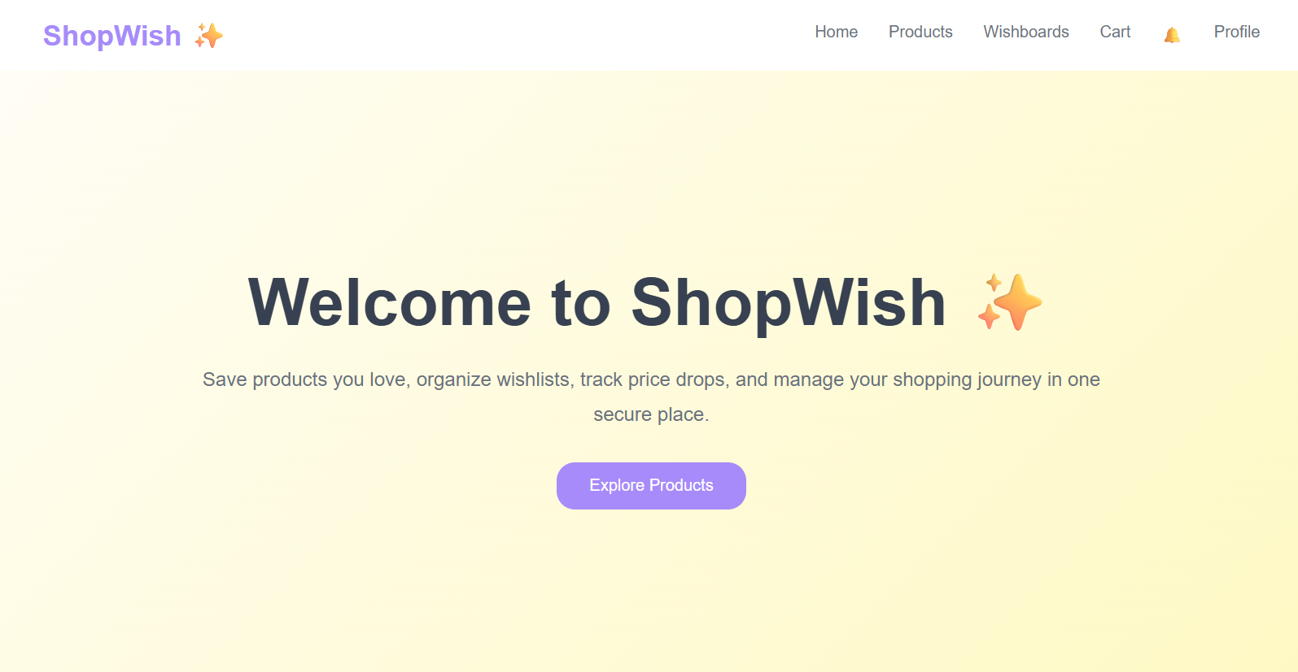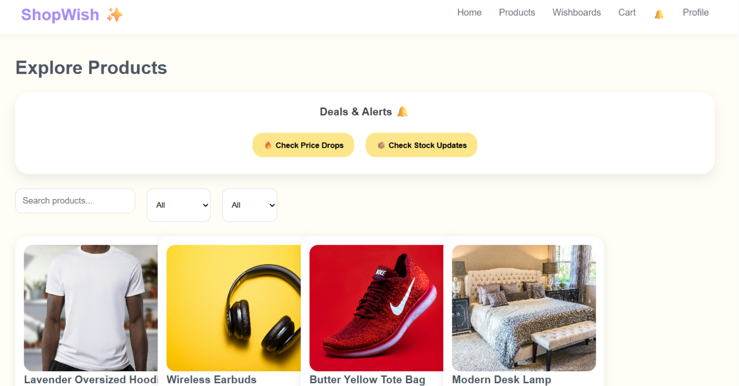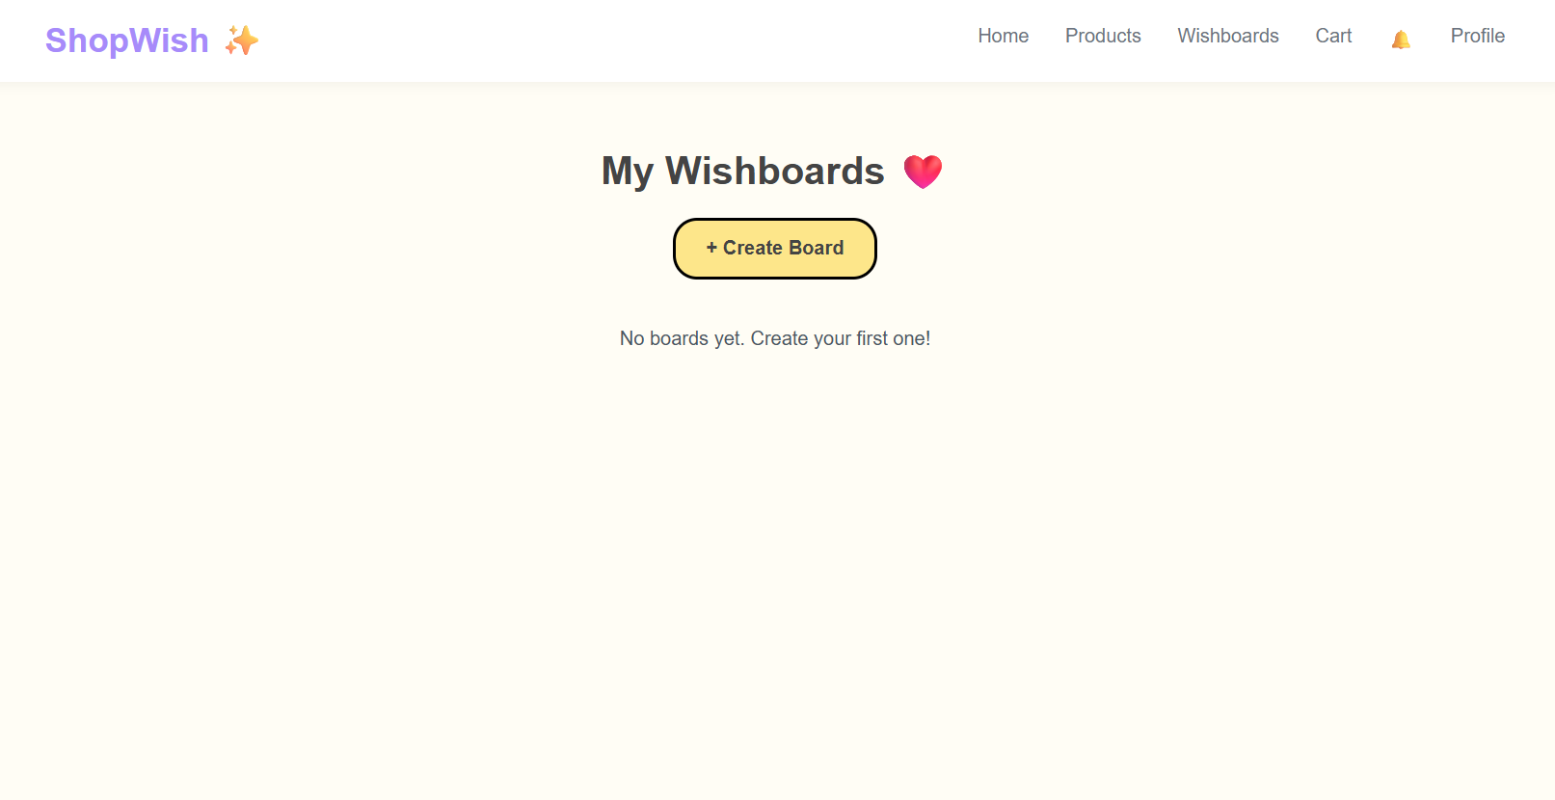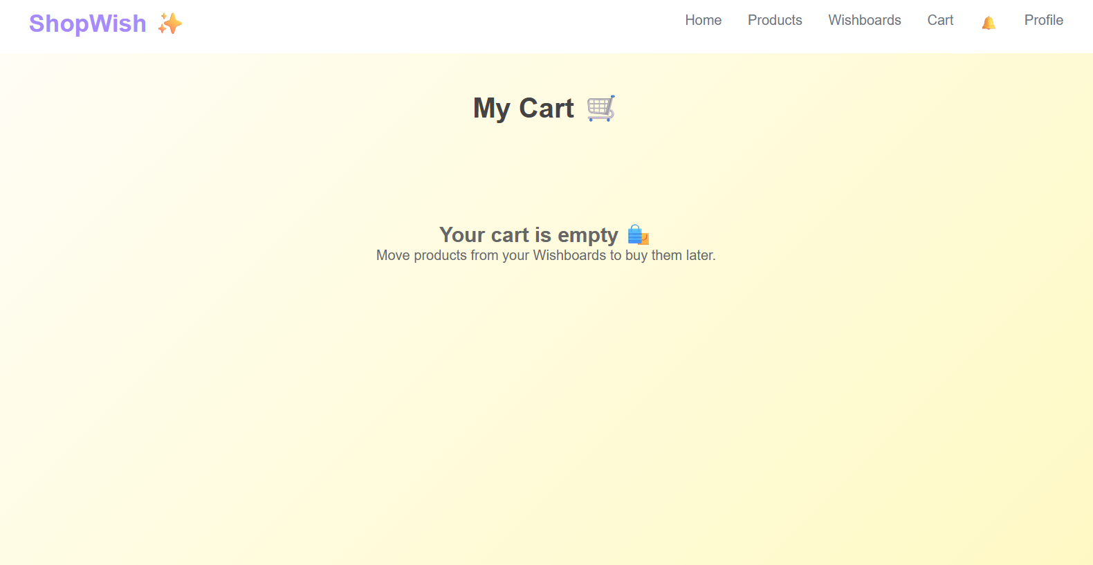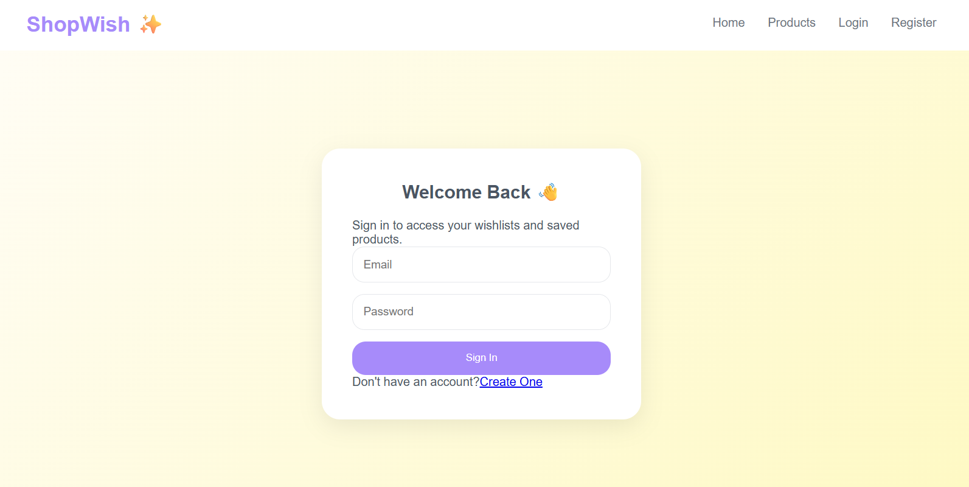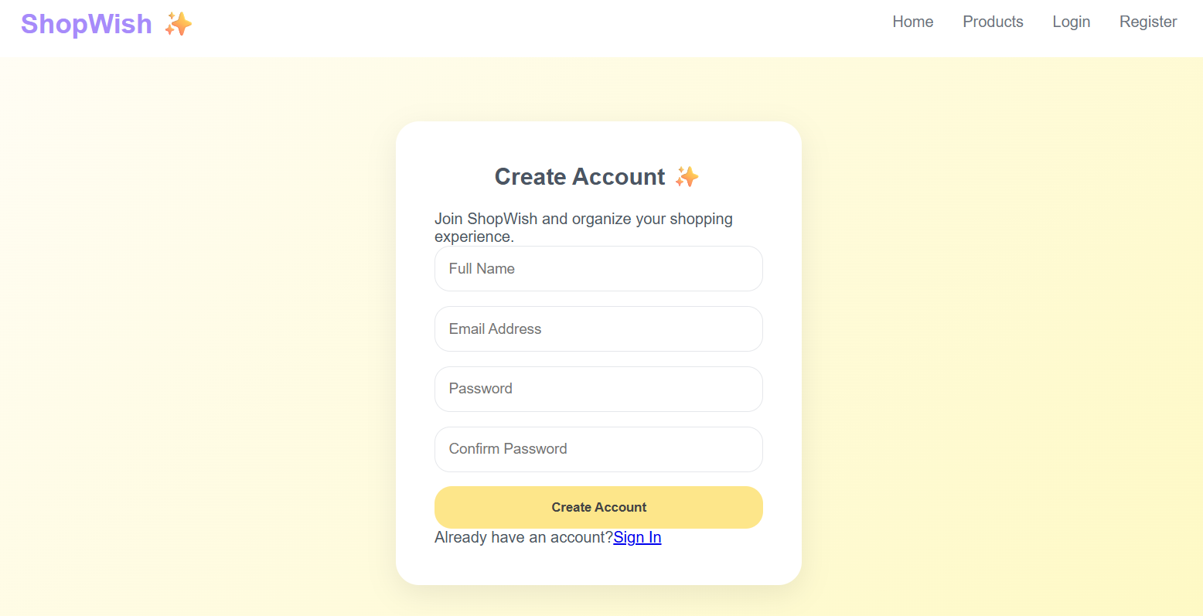

Sample code snippets

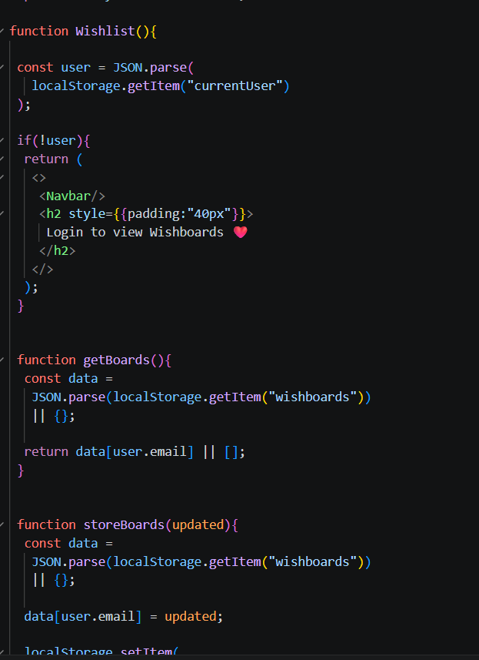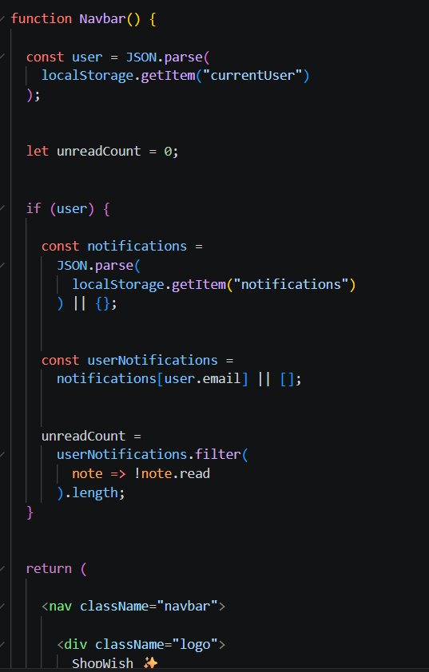

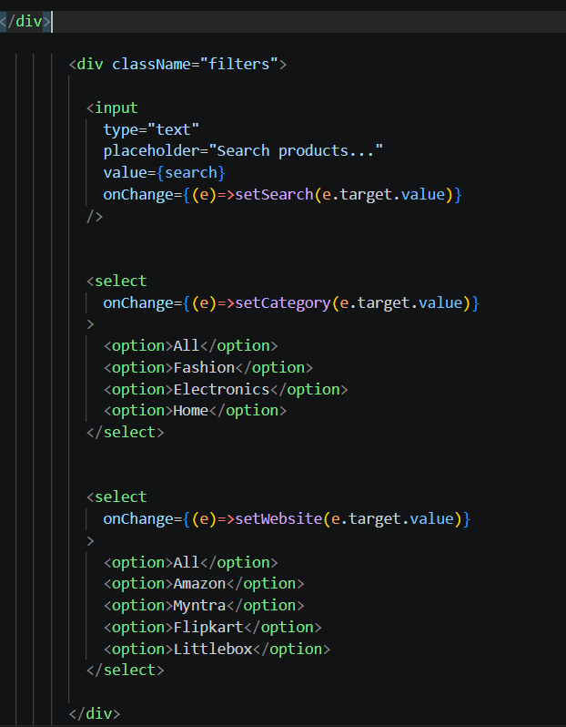

Installation/setup instructions

The GOglobe Integrated Tourism Platform is simple to install because it is built entirely using HTML, CSS, and JavaScript. It does not require any external frameworks or databases. The setup can be completed in just a few steps.

First, download or copy the complete GOglobe project folder to your local computer. If it is shared as a ZIP file, extract it using any standard extraction tool. Make sure all files especially index.html, style.css, and script.js (if included) are in the same folder.

Next, open the folder in a text editor like Visual Studio Code or Sublime Text to review or modify the code. To run the project, simply double-click on the index.html file or right-click and select “Open with Browser.” The website will open and function in any modern browser such as Google Chrome, Microsoft Edge, or Firefox.

No installations or dependencies are needed. The project is fully self-contained and works offline, making it ideal for classroom demonstrations and educational submissions.

User manual or guide

When you open the GOglobe platform, the homepage displays the main navigation bar with options like Login, Register, Destinations, and Travel Assistance. Users can begin by clicking the Login or Register buttons. A clean, half-page form will appear where users can enter their details to simulate login or registration.

Once logged in, users can explore Top Global Destinations, view beautiful travel images, and get information about each place. The Travel Assistance section offers quick options like medical help, hotel booking, and transportation support all designed for educational simulation.

